|  |
| --- |
| | **USER MANUAL** | | --- |  | **Document information** | | | --- | --- | | Project Name | Exchange Rate in Billing Document | | Module | SD – Sales and Distribution | | Process | Stock Sales | | Created by | Group 7 | | Version | 1.0 | | Date | 20/11/2024 | |
|  |
|  |

| **Change History** | | | | | |
| --- | --- | --- | --- | --- | --- |
| Changed date | Items have been changed | Changed content/Reason | Updated by | Type  (A/C/D) | Version |
| 20/11/2024 | All | First Release | Trang Nguyen  Thu Le | A | 1.0 |
| ***A*** *– Create* ***C*** *– Change* ***D*** *– Delete* | | | | | |

| **Advisor Signature** | | | | |
| --- | --- | --- | --- | --- |
|  | **Full name & Role** | **Signature** | **Date** | **Note** |
| **Created by** | **Trang Nguyen**  [trangntss160256@fpt.edu.vn](mailto:trangntss160256@fpt.edu.vn)  FU - Student  **Thu Le**  [thultbss160283@fpt.edu.vn](mailto:thultbss160283@fpt.edu.vn)  FU - Student |  | 20/11/2024 |  |
| **Reviewed by** | **Phuong Vo**  [phuongvtt1@fpt.com](mailto:phuongvtt1@fpt.com)  FPT Software - Functional Consultant |  | 22/11/2024 |  |
| **Approved by** | **Phuong Vo**  [phuongvtt1@fpt.com](mailto:phuongvtt1@fpt.com)  FPT Software - Functional Consultant |  | 22/11/2024 |  |

| **FU Signature** | | | | |
| --- | --- | --- | --- | --- |
|  | **Full name & Role** | **Signature** | **Date** | **Note** |
| **Reviewed by** | **Giao Nguyen**  [giaonhh@fpt.edu.vn](mailto:giaonhh@fpt.edu.vn)  FU - Lecturer |  |  |  |
| **Approved by** |  |  |  |  |

| **Table of Contents** |
| --- |

**1 OVERVIEW 6**

1.1 The process used in the guide document 6

**2 USER MANUAL 7**

2.1 Context 7

2.2 Create an Inquiry 7

*2.2.1 Transaction Code 7*

*2.2.2 Detail Implementation 7*

2.3 Create a Quotation 10

*2.3.1 Transaction Code 10*

*2.3.2 Detail Implementation 10*

2.4 Create Sales Order 17

*2.4.1 Transaction Code 17*

*2.4.2 Detail Implementation 18*

2.5 Create Outbound Deliveries 25

*2.5.1 Transaction Code 25*

*2.5.2 Detail Implementation 25*

2.6 Pick Materials and Post Goods Issue 26

*2.6.1 Transaction Code 26*

*2.6.2 Detail Implementation 26*

2.7 Create Billing Documents 31

*2.7.1 Transaction Code 31*

*2.7.2 Detail Implementation 31*

2.8 Post Billing Documents & Display Accounting Documents 34

*2.8.1 Transaction Code 34*

*2.8.2 Detail Implementation 34*

2.9 Change Billing Documents 38

*2.9.1 Transaction Code 38*

*2.9.2 Detail Implementation 38*

2.10 Post Billing Documents & Display Accounting Documents 42

*2.10.1 Transaction Code 42*

*2.10.2 Detail Implementation 42*

# OVERVIEW

## 1.1 The process used in the guide document

| **BBP No** | **Definition** | **Note** |
| --- | --- | --- |
| SD01 - Stock Sales Process | In SAP, the stock sales process refers to the process of delivering goods to a customer. |  |

**Stock Sales Process Description:**

The Stock Sales process starts with an Inquiry followed by a Quotation. These 2 steps are optional & mostly kept outside SAP. The next step is to Create a Sales Order upon receiving confirmation from the customer for placing the Sales Order. Once the Material is ready for Delivery, a delivery document is created based on the Sales Order. Delivery consists of a few steps, like picking, and the goods officially leaving the warehouse when the Post Goods Issue (PGI) is done in the system. The impact of PGI is that it reduces the valuation and quantity of stock. After delivery, an invoice is generated and sent to the customer, detailing the products delivered and the total amount due.

In the process above, the enhancements which our team develops for the project are:

* Consistent exchange rate type and value, which are used in the Billing Document, are updated exactly from the exchange rate table in T-code OB08, and ensure that they are reflected correctly in the journal entries
* The exchange rate type can correspond until the end of the process
* Set editable for exchange rate field in the Billing Document, allowing it to affect the accounting document after posting the billing document in the process

# USER MANUAL

## 2.1 Context

**The SAP Stock Sales process** is a sequence of activities involved in creating, processing, and fulfilling customer orders. By utilizing transactions such as VA01, VL01N, VL02N, VF01, VF02, etc, the SAP system optimizes the process's various stages, from receiving customer requests to issuing invoices and collecting payments. The primary objective is to ensure accuracy, efficiency, and transparency in sales operations, while enhancing customer satisfaction. The process encompasses steps such as creating sales orders, generating outbound delivery, picking goods & posting goods issues, and creating & posting billing documents.

In this project, some new enhancements will be released in the system. The new enhancements are the exchange rate type and value can be synchronized correspondingly through the process; the exchange rate field can be updated exactly the value and type from the table in T-code OB08; can be editable in the billing document, and simultaneously, it also affects the accounting documents.

## 2.2 Create an Inquiry

### 2.2.1 Transaction Code

| **T-code** | **Description** |
| --- | --- |
| VA11 | Create Sales Inquiries |
| VA12 | Change Sales Inquiries |
| VA13 | Display Sales Inquiries |

### 2.2.2 Detail Implementation

In the space *Sales and Distribution*, and in the section *Sales Person,* please use the *Create Sales Inquiries* app. Click on the application.

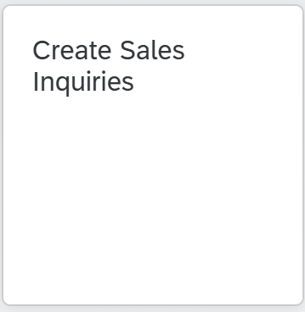

On the *Create Inquiry* screen, make the following entries then click on 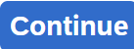 (or press *Enter*):

| **No** | **Field name** | **R/O/D** | **Description and Example** |
| --- | --- | --- | --- |
| 1 | Inquiry Type | R | Choose: **ZIN7** |
| 2 | Sales Organization | R | Default: **FU24** |
| 3 | Distribution Channel | R | Default: **FU** |
| 4 | Division | R | Default: **FD** |

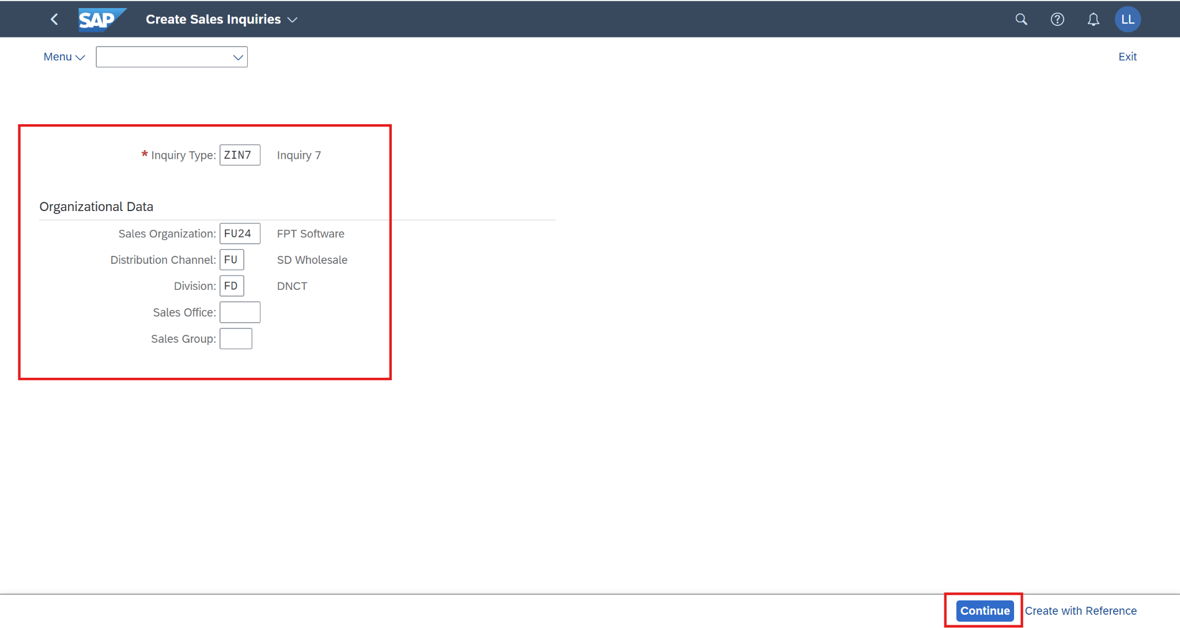

On the *Create Inquiry 7:Overview* screen: Input the following information

| **No** | **Field name** | **R/O/D** | **Description** |
| --- | --- | --- | --- |
| 1 | Sold-to Party | R | Customer number who placed an order: **1003154** (Business partner number) |
| 2 | Ship-to Party | R | The customer number to which the goods will be delivered. Ship-to can be different from sold-to: **1003154** (Business partner number) |
| 3 | Cust. Reference | O | Customer three-digit number: **214** (your number ###) |
| 4 | Cust. Ref. Date | O | The date on which the customer created the order: **11/23/2024** |
| 5 | Valid From | O | **11/23/2024** |
| 6 | Valid To | O | **12/23/2024** |
| 7 | Req. Deliv. date | R | The customer requested a delivery date: **12/23/2024** |
| 8 | Material | R | Parts number: **OHMT2007** |
| 9 | Order Quantity | R | **1** |

Then click on  to save the request.

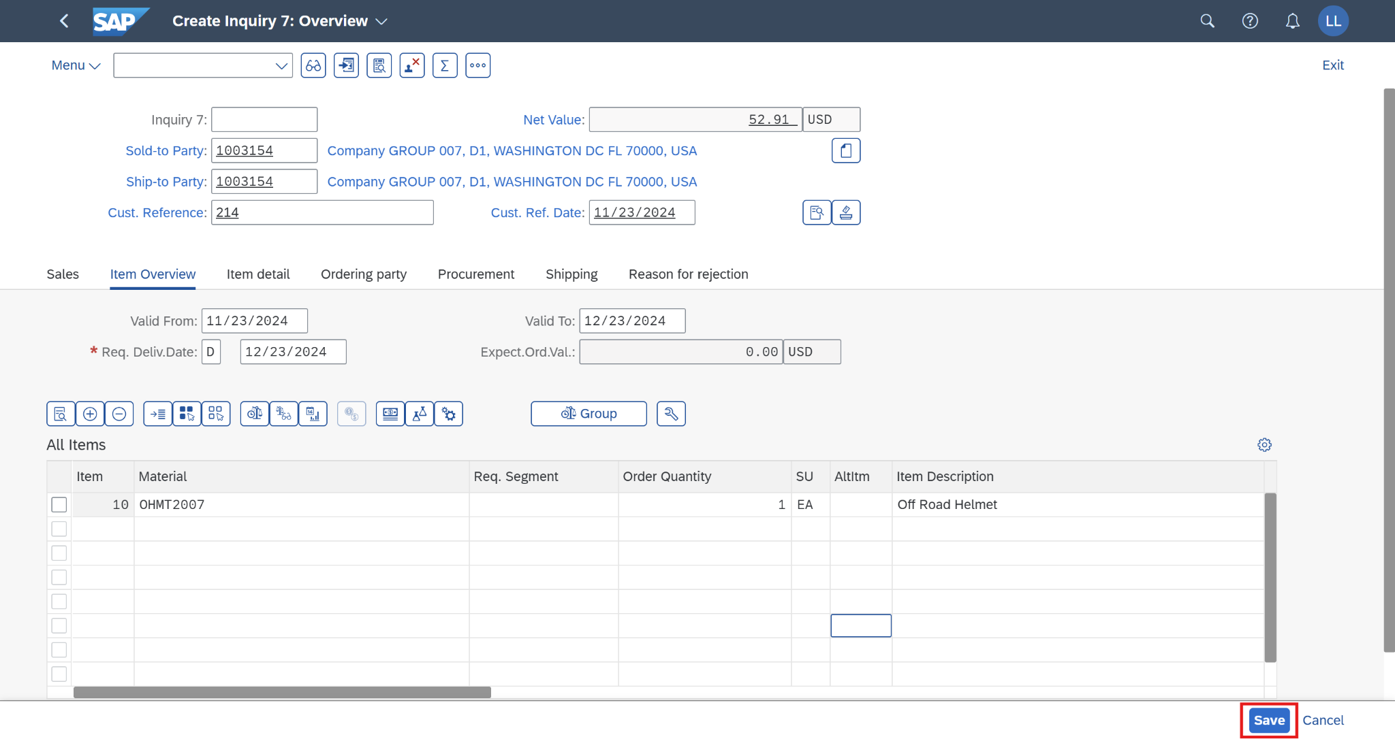

The SAP system will assign a unique number to the request. Make a note of it.

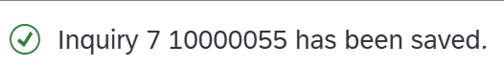

An inquiry has been created successfully. Click on  to return to the SAP Fiori launchpad.

## 2.3 Create a Quotation

### 2.3.1 Transaction Code

| **T-code** | **Description** |
| --- | --- |
| VA21 | Create Quotations |
| VA22 | Change Quotations |
| VA23 | Display Quotations |

### 2.3.2 Detail Implementation

In the space *Sales and Distribution*, and in the section *Sales Representative,* please use the *Manage Sales Quotations* app. Click on the application.

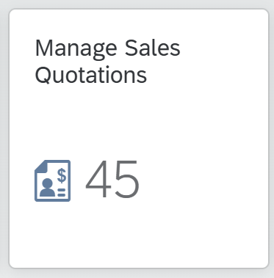

On the *Manage Sales Quotations* screen, choose 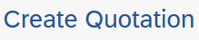

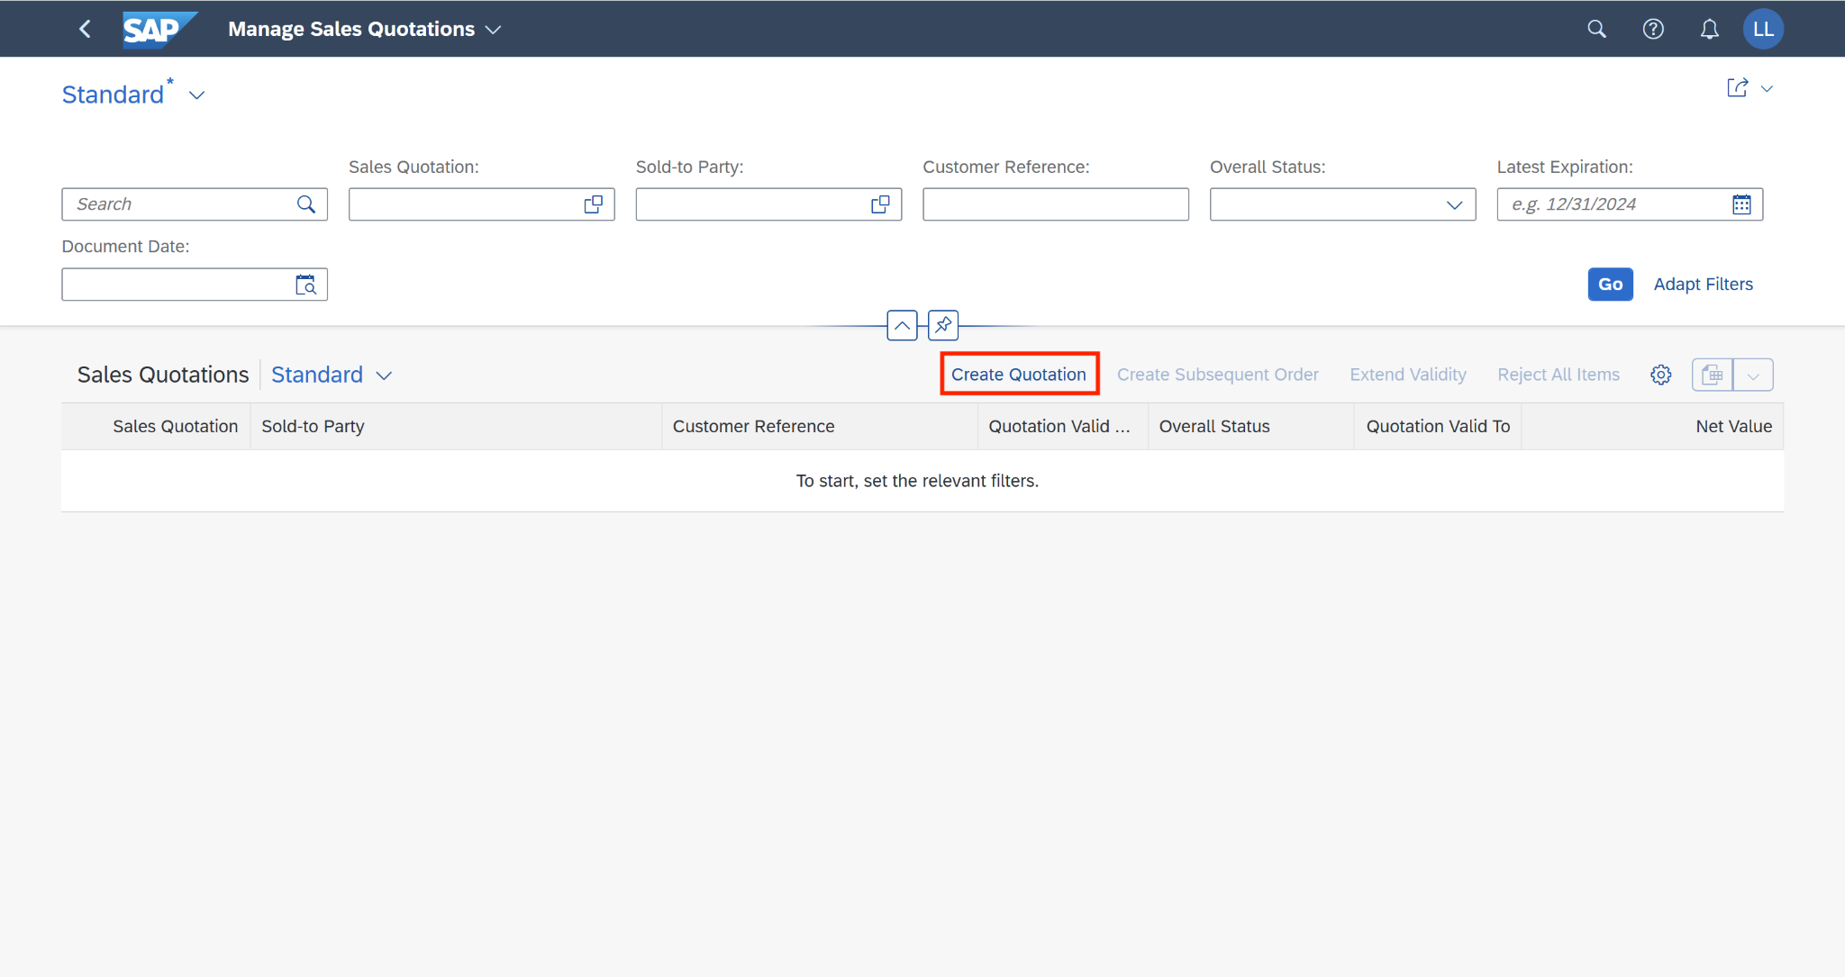

On the *Create Quotations* screen, enter the quotation type, sales organization, distribution channel, and division following the table below then click on 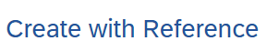:

| **No** | **Field name** | **R/O/D** | **Description and Example** |
| --- | --- | --- | --- |
| 1 | Quotation Type | R | Choose: **ZQT7** |
| 2 | Sales Organization | R | Default: **FU24** |
| 3 | Distribution Channel | R | Default: **FU** |
| 4 | Division | R | Default: **FD** |

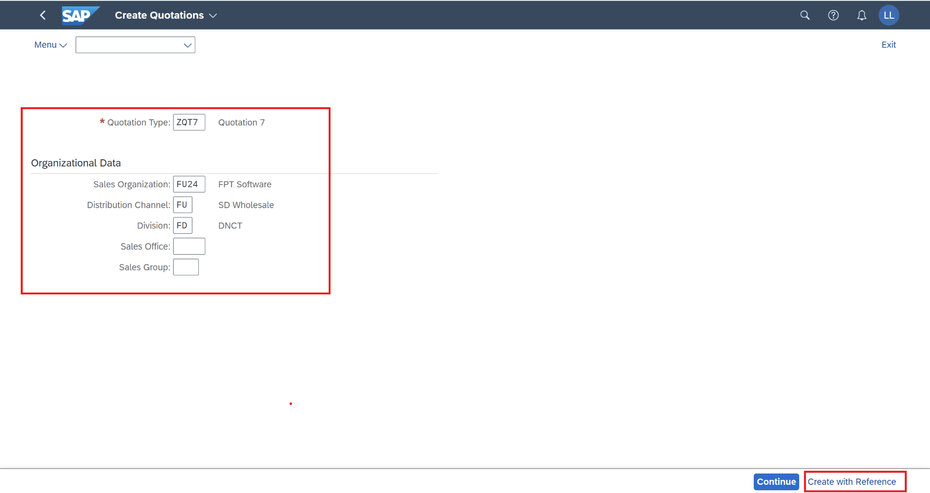

On the *Create with Reference* screen, enter **the inquiry number** (the number was created in the previous step)**,** and click on *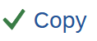.*

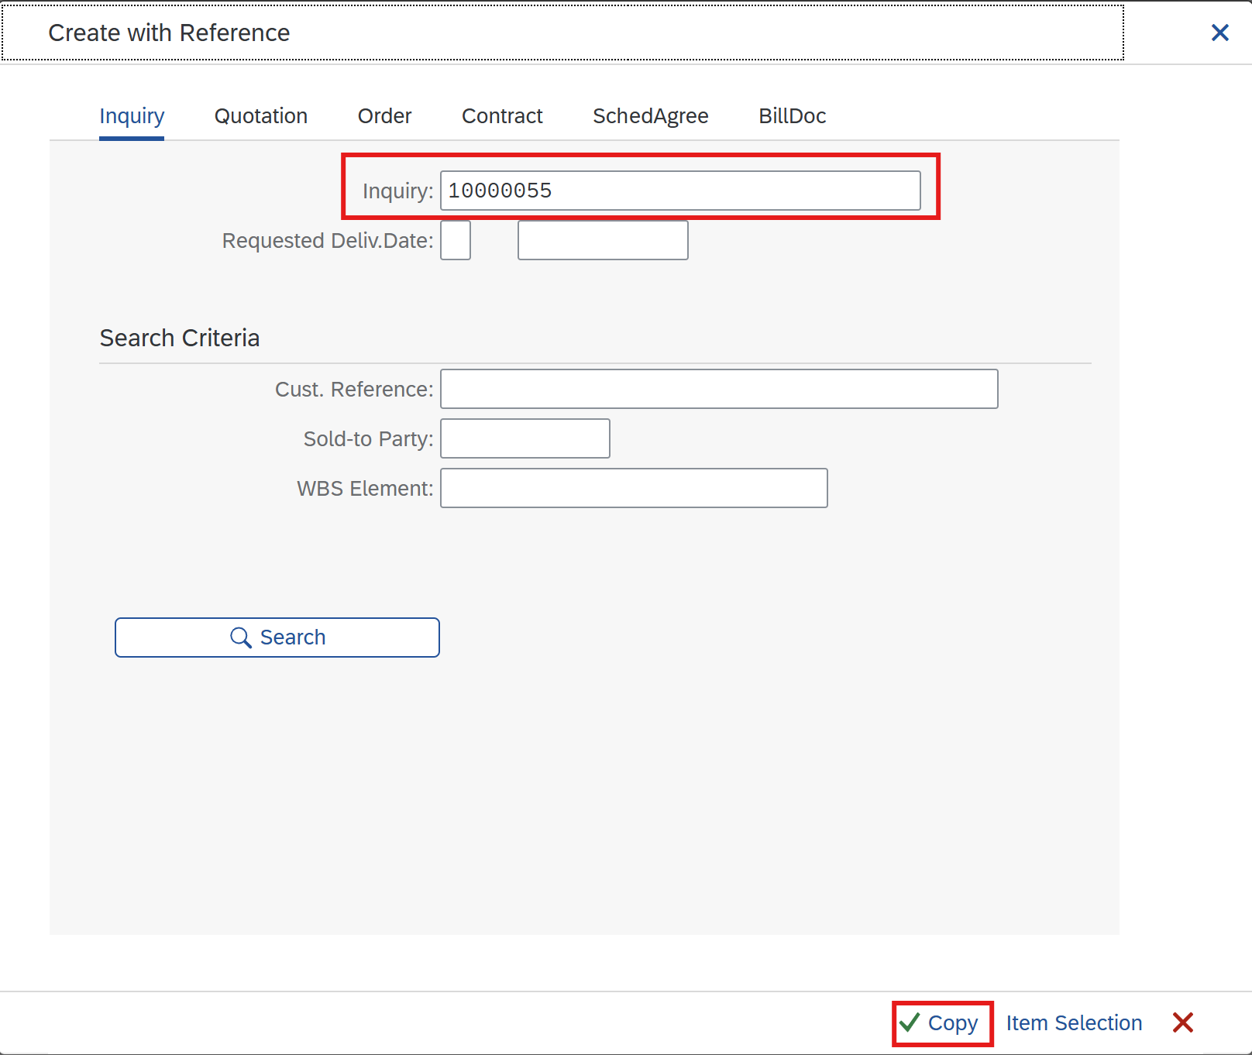

On the *Create Quotation 7: Overview* screen, enter the following information:

| **No** | **Field name** | **R/O/D** | **Description** |
| --- | --- | --- | --- |
| 1 | Cust. Reference | O | **214** |
| 2 | Cust. Ref. Date | O | **11/23/2024** |
| 3 | Valid To | R | **12/23/2024** |

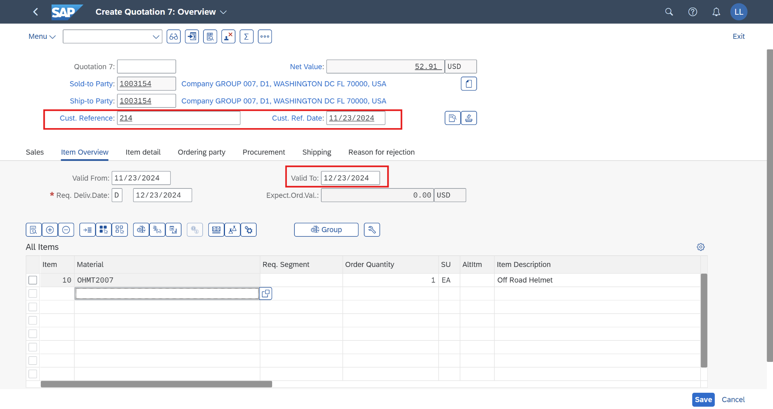

The price will display automatically from a list price. If a price adjustment is needed, go to the tab *Conditions* in the item line.

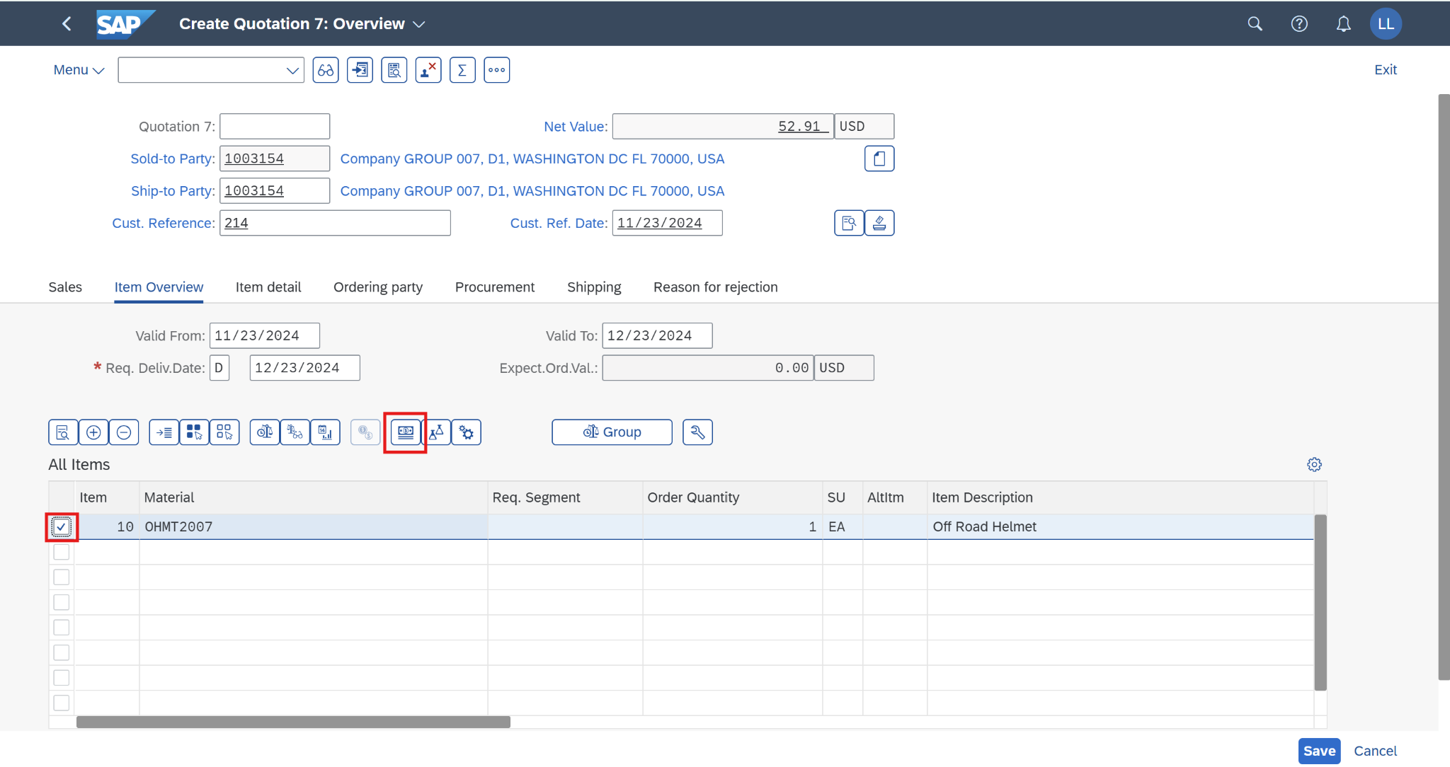

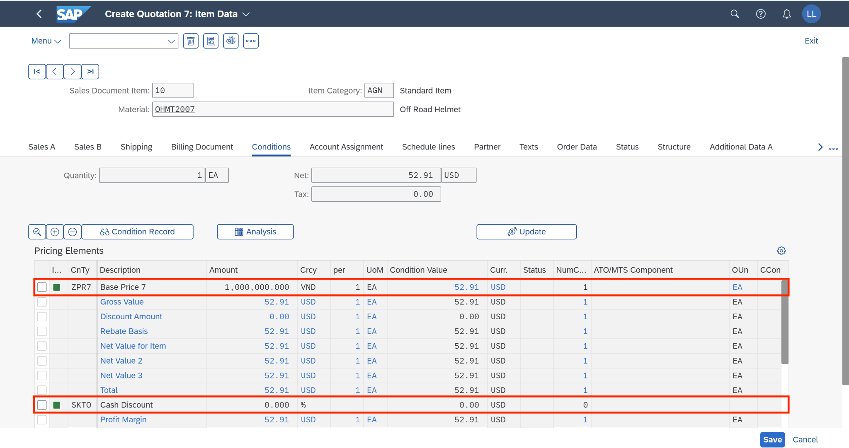

A detailed pricing screen is popped out, in here, we can see how the item’s net value is determined.

If we would like to adjust the price, we can use the following discount condition types for the adjustment.

| **Discount** | **Description** |
| --- | --- |
| ZPR7 | Base Price 7 |
| K004 | Material Group |
| RA00 | % Discount from Net |
| HD00 | Freight |
| MWST | Output Tax |
| SKTO | Cash Discount |

Choosethe *Insert Row* button to add more condition types.

After adding the value (% or $), press *Enter*, andthe newly added condition types will jump to their designed position.

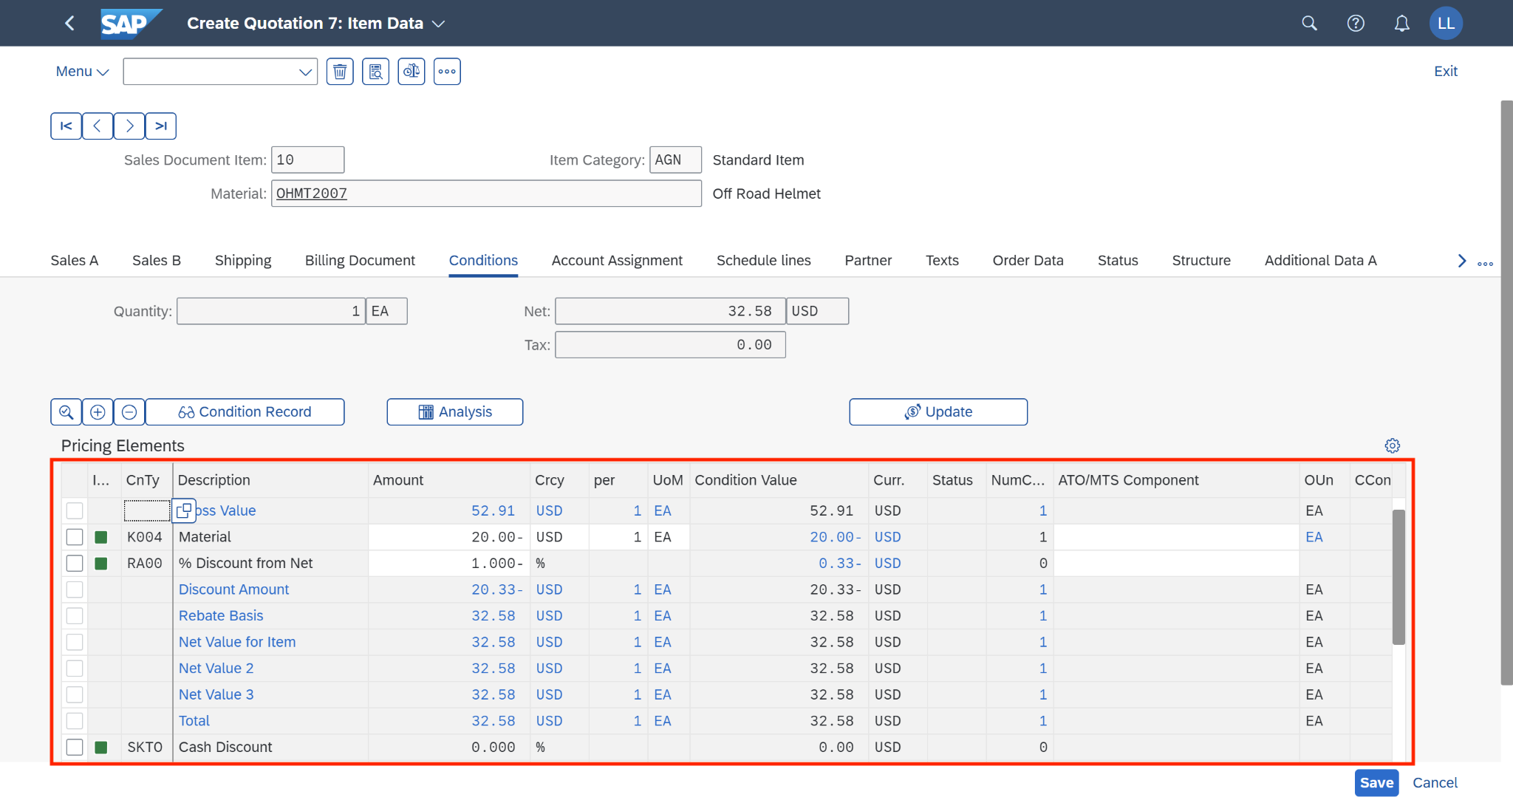

After maintaining the price, we check *Incompletion Log* to ensure the document is completed by going to *Menu > Edit > Incompletion Log*.

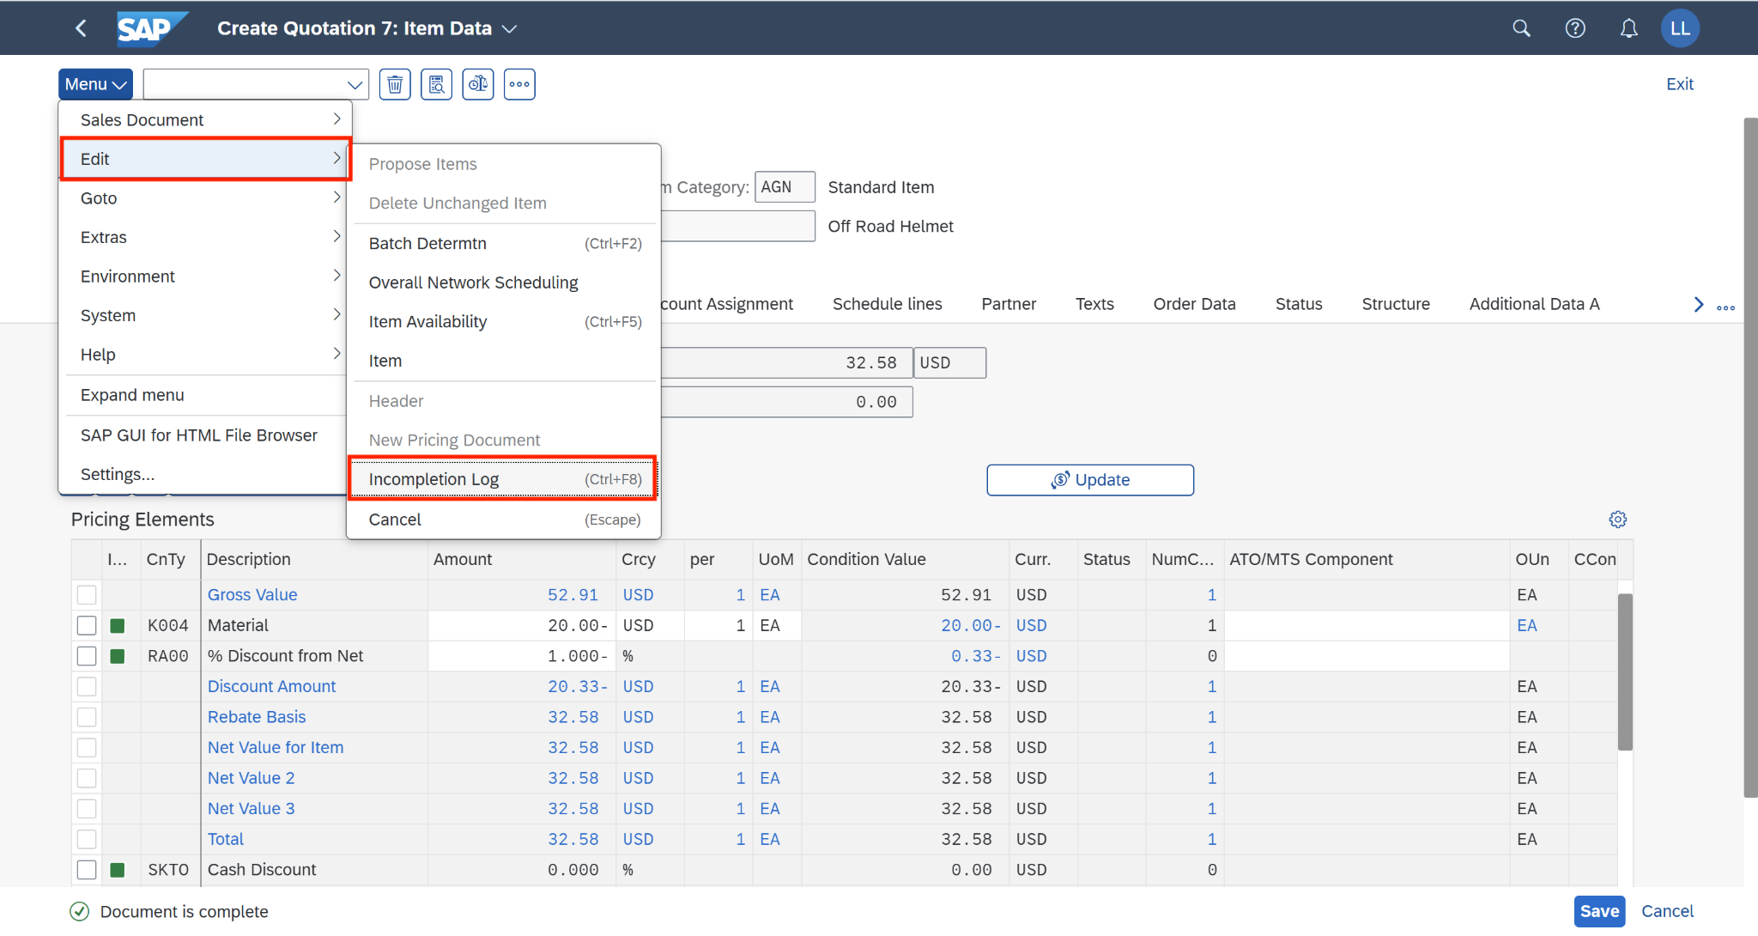

When the document is completed, a small message will pop out to notify:

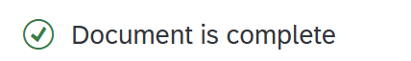

Click on  to save the request. The SAP system will assign a unique number to the request. Make a note of it.

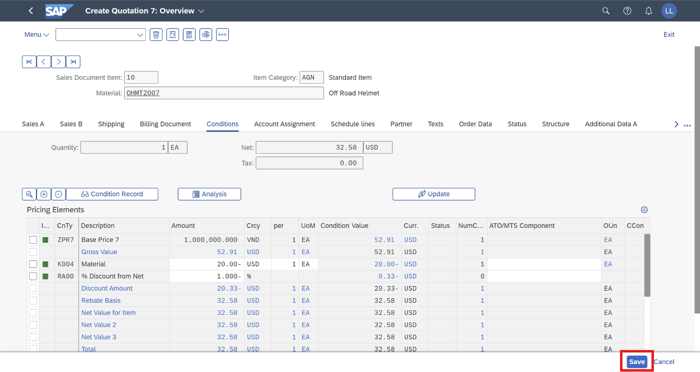

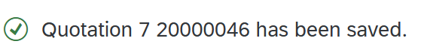

A quotation has been created successfully. Click on  to return to the SAP Fiori launchpad.

## 2.4 Create Sales Order

### 2.4.1 Transaction Code

| **T-code** | **Description** |
| --- | --- |
| VA01 | Create Sales Documents |
| VA02 | Change Sales Documents |
| VA03 | Display Sales Documents |

### 2.4.2 Detail Implementation

Before going to create the sales order, please go to the *Manage Business Partner Data* app to check the business partner’s exchange rate type:

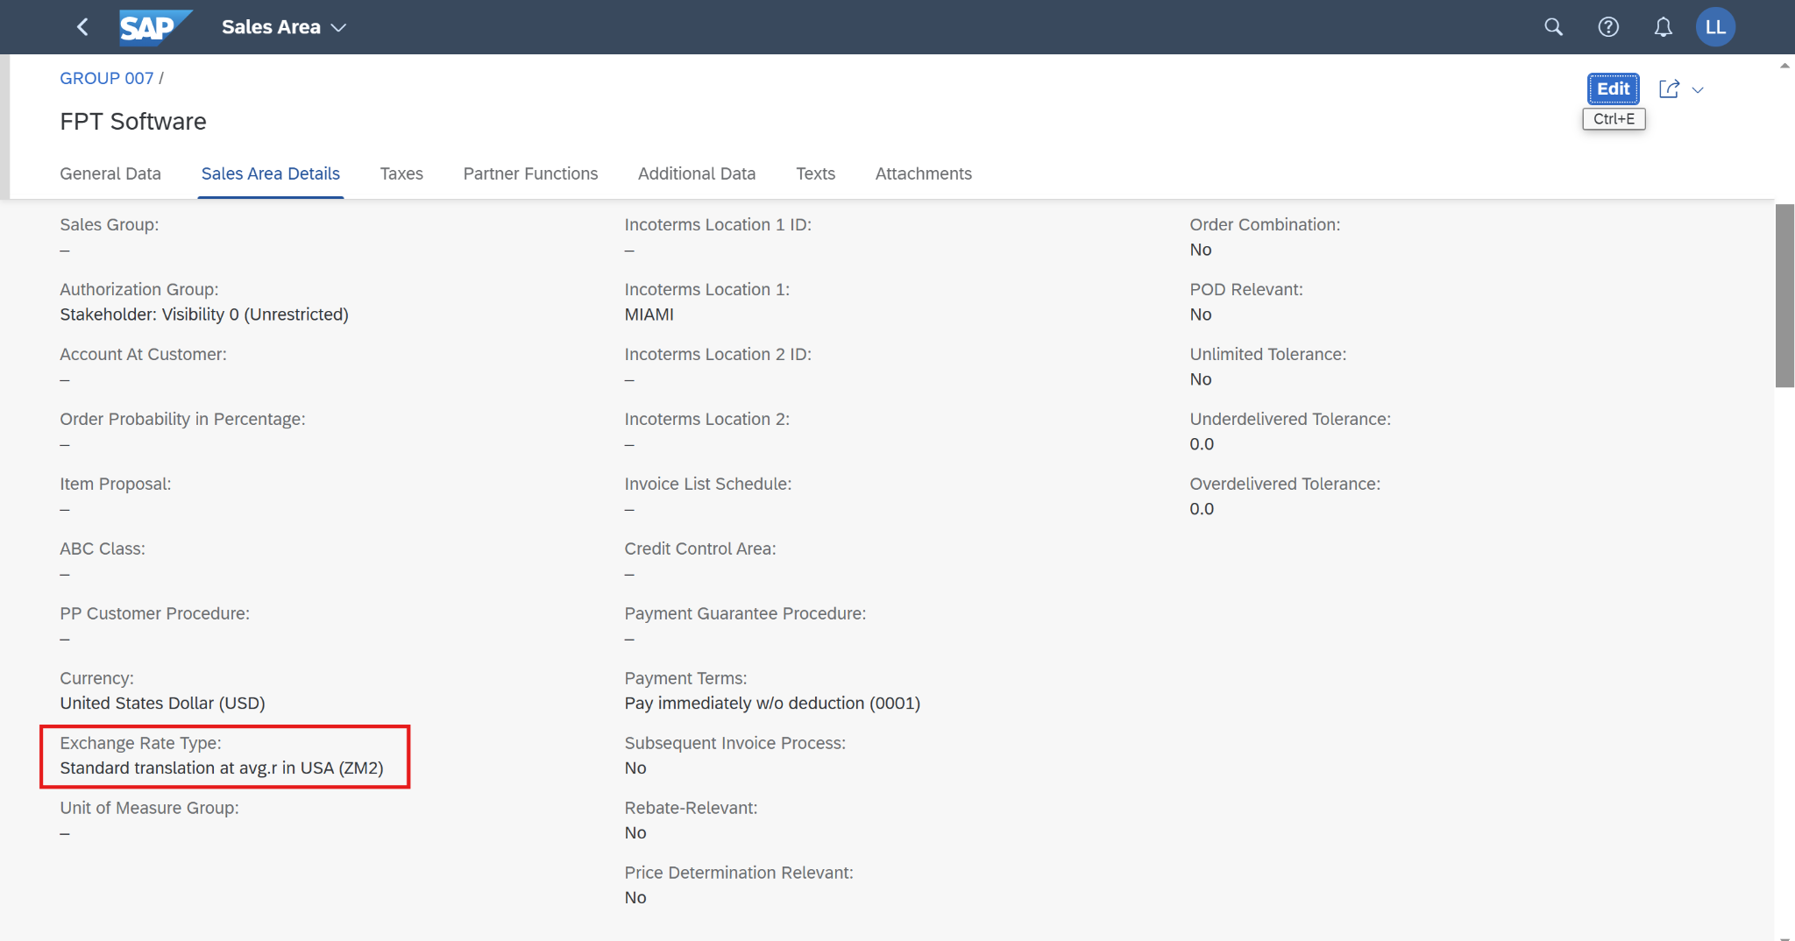

In the space *Sales and Distribution*, and in the section *Sales Representative,* please use the *Manage Sales Orders* app. Click on the application.

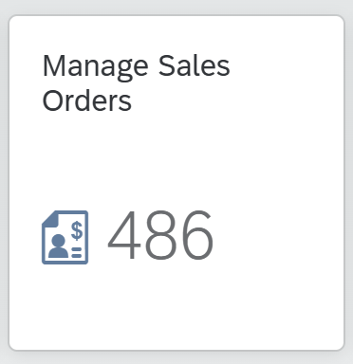

Click on *Create > Create Sales Order VA01* on the *Manage Sales Orders* screen.

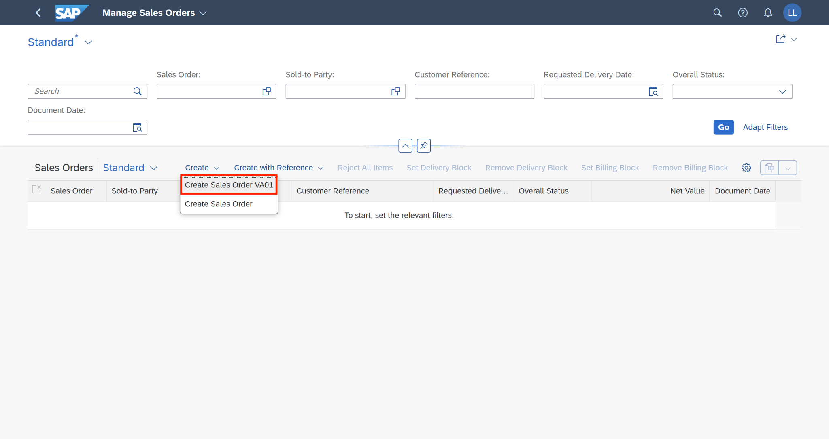

On the *Create Sales Order - VA01* screen, enter the order type, sales organization, distribution channel, and division following the table below, then click on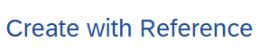*.*

| **No** | **Field name** | **R/O/D** | **Description and Example** |
| --- | --- | --- | --- |
| 1 | Order Type | R | Choose: **ZOR7** |
| 2 | Sales Organization | R | Default: **FU24** |
| 3 | Distribution Channel | R | Default: **FU** |
| 4 | Division | R | Default: **FD** |

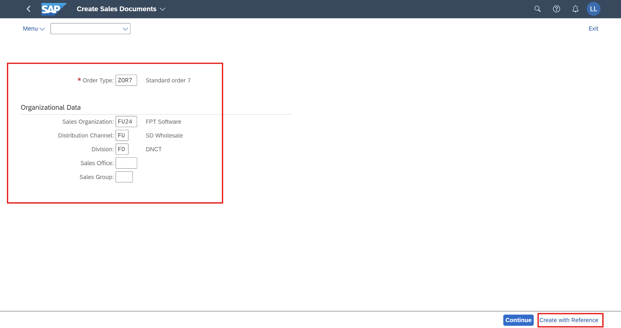

The *Create with Reference* screen will pop out, enter **your quotation number** in the previous step and choose*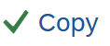.*

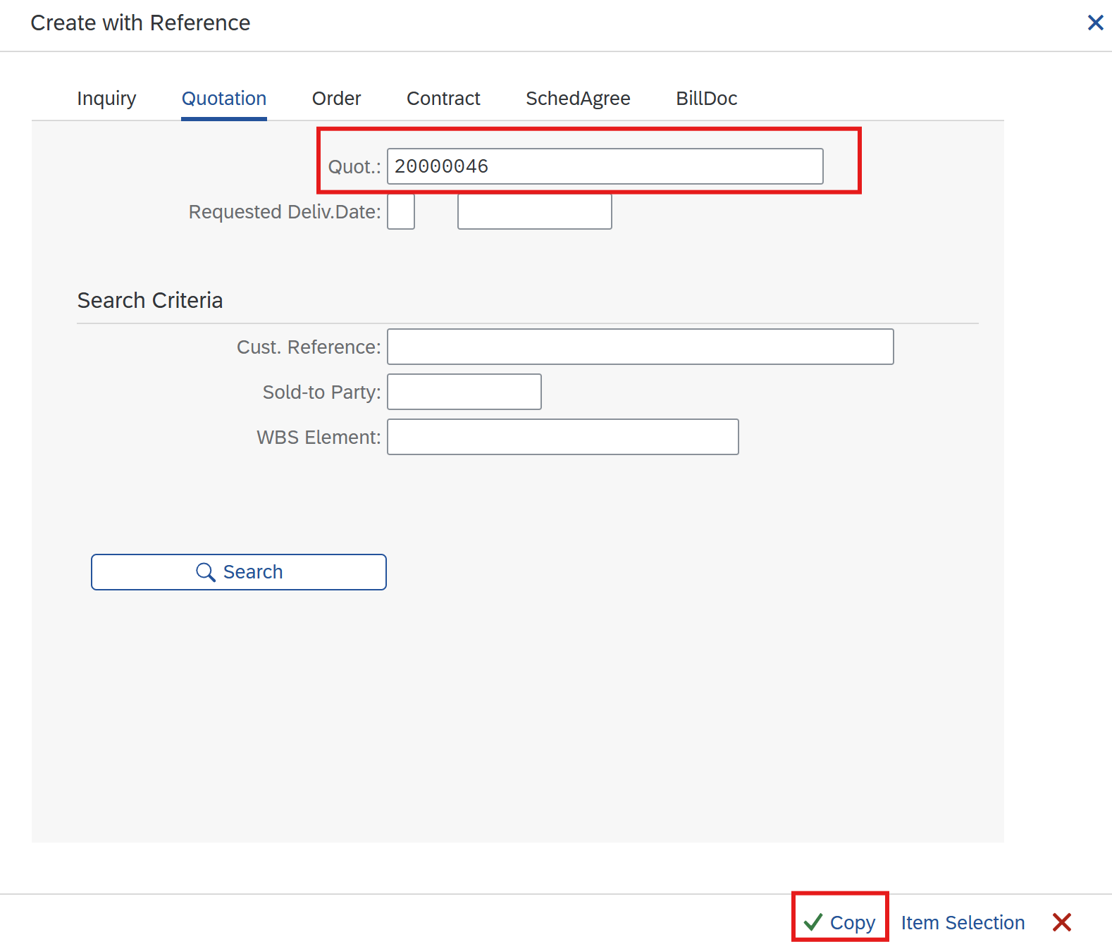

Next, on the *Create Standard Order 7: Overview* screen, enter the following information:

| **No** | **Field name** | **R/O/D** | **Description** |
| --- | --- | --- | --- |
| 1 | Cust. Reference | O | **214** |
| 2 | Cust. Ref. Date | O | **11/23/2024** |

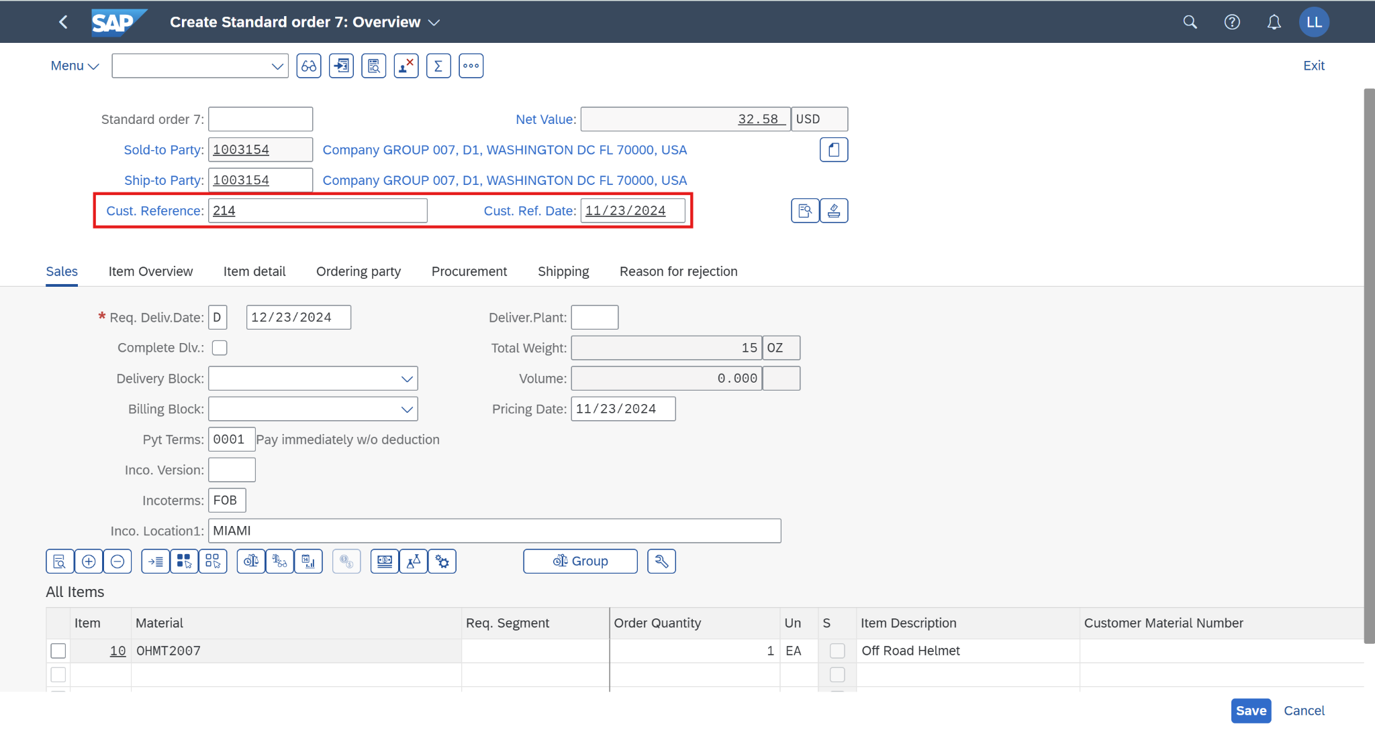

Check the *Incompletion Log* to ensure the document is completed by going to *Menu > Edit > Incompletion Log*.

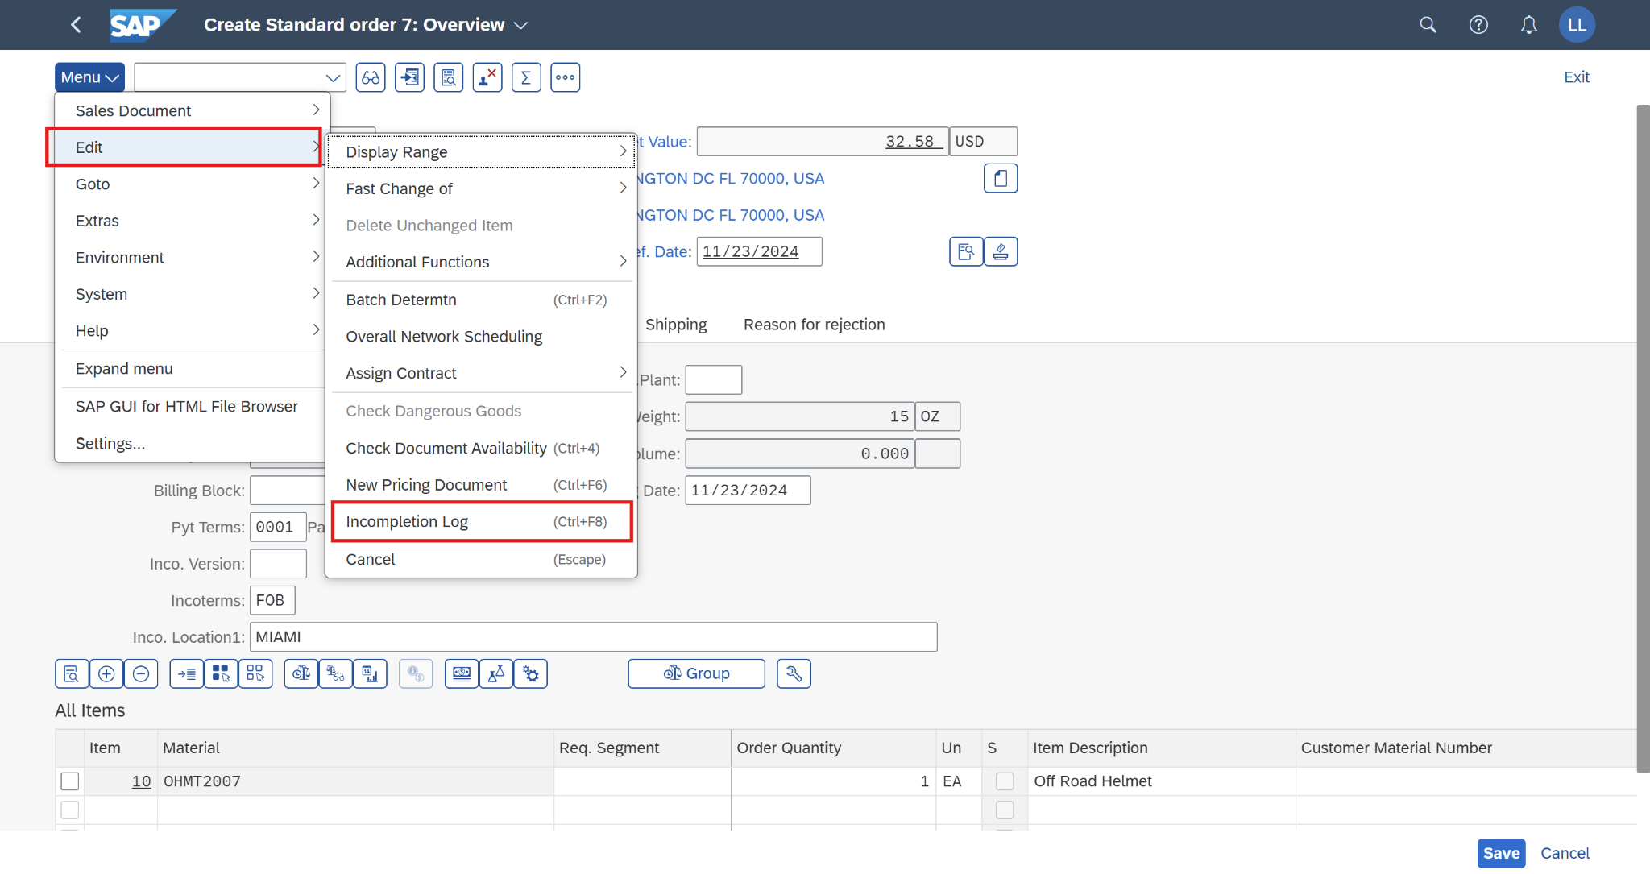

When the document is completed, a small message will pop out to notify:



Click on  to save the request. The SAP system will assign a unique number to the request. Make a note of it.

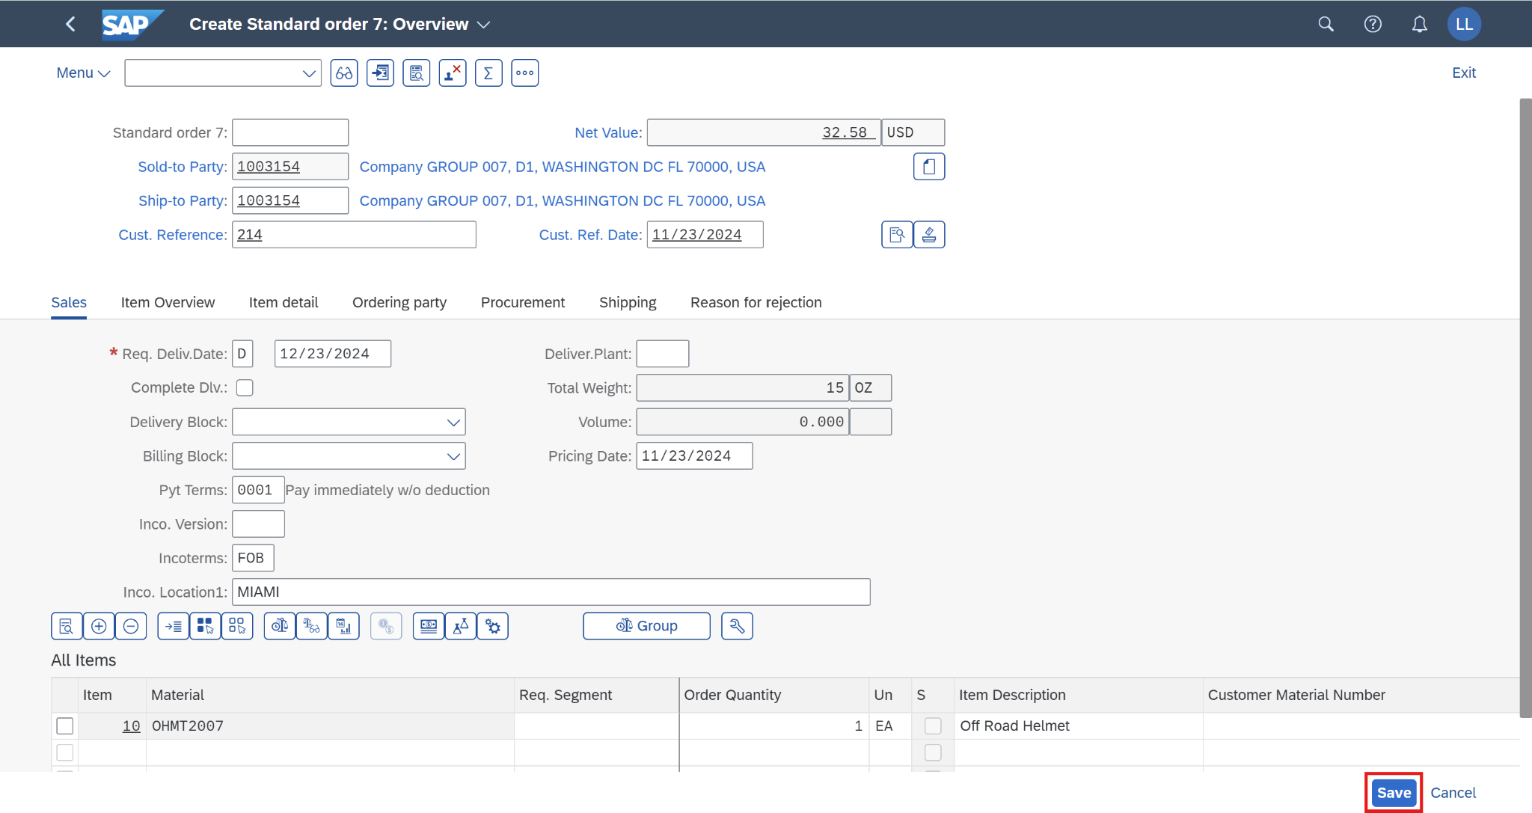

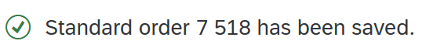

A sales order has been created successfully.

Exchange rate value and type in T-code OB08:

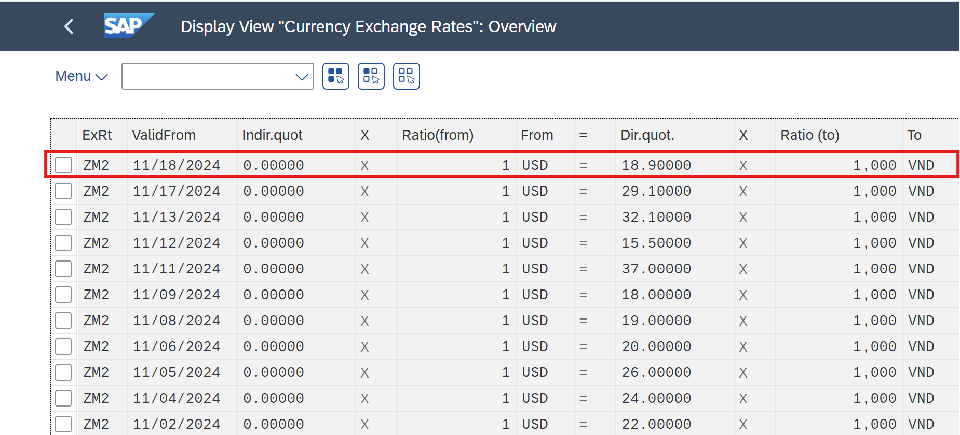

Then go to T-code VA03 to display your sales order. You can see the exchange rate value and type are updated from the table in T-code OB08:

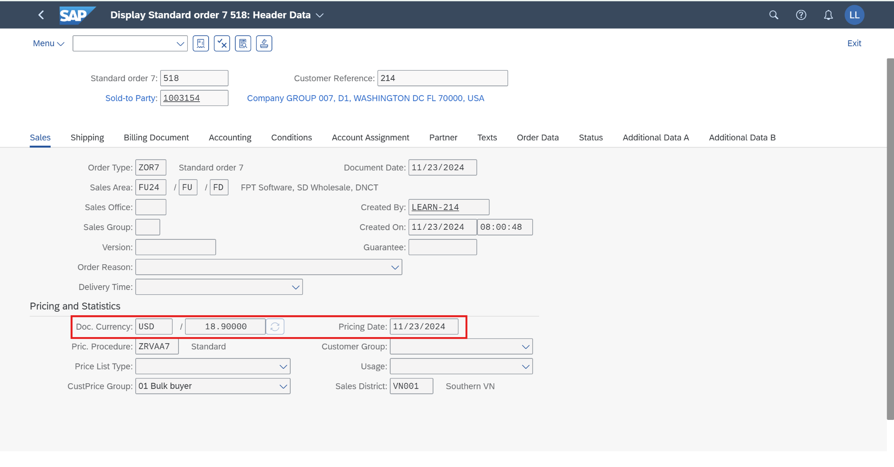Click on  to return to the SAP Fiori launchpad.

## 2.5 Create Outbound Deliveries

### 2.5.1 Transaction Code

| **T-code** | **Description** |
| --- | --- |
| VL01N | Create Outbound Delivery with Order Reference |
| VL02N | Change Outbound Delivery |
| VL03N | Display Outbound Delivery |

### 2.5.2 Detail Implementation

In the space *Sales and Distribution*, and in the section *Warehouse Employee*, please use the *Create Outbound Deliveries* app. Click on the application.

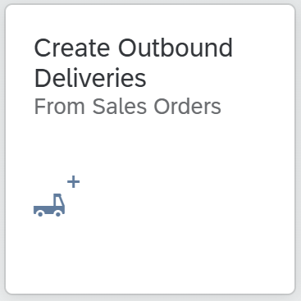

On the *Create Outbound Deliveries* screen, in the *Ship-to Party* field enter **your business partner number 1003154**, the *Shipping Point* field as **FU24**, and remove the content in the *Planned Creation Date* field, **your sales document 518** in the *Sales Document* field. Choose  (or press *Enter*). The sales order will be displayed.

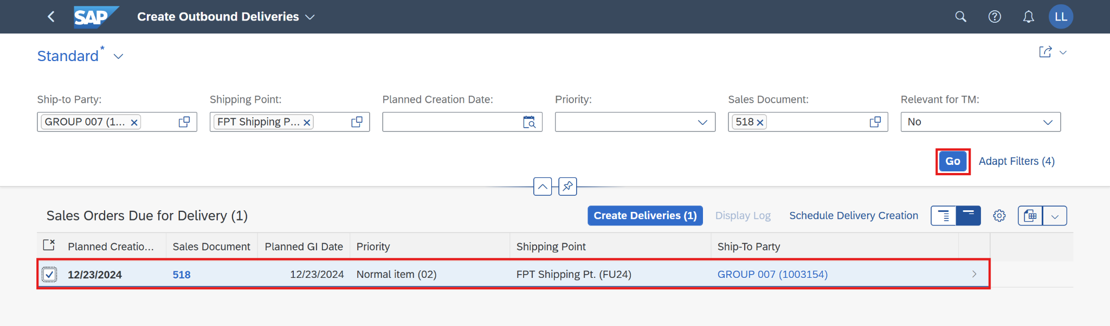

Then select the sales document and choose the button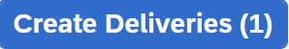. You will see that the sales document is no longer available. Additionally, you will receive confirmation that your outbound delivery has been created.

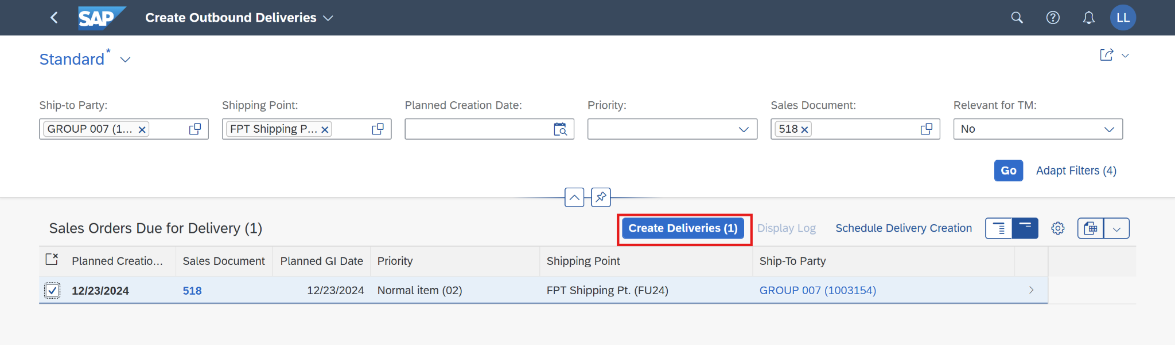

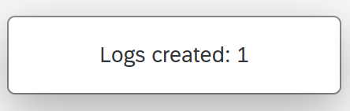

Outbound delivery has been created successfully. Click on  to return to the SAP Fiori launchpad.

## 2.6 Pick Materials and Post Goods Issue

### 2.6.1 Transaction Code

| **T-code** | **Description** |
| --- | --- |
| VL02N | Change Outbound Delivery |

### 2.6.2 Detail Implementation

In the space *Sales and Distribution*, and in the section *Warehouse Employee*, please use the *Manage Outbound Deliveries* app. Click on the application.

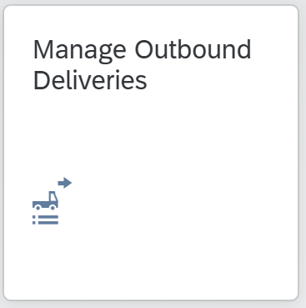

On the *Manage Outbound Deliveries* screen, as the *Shipping Point* enter **FU24,** as*Ship-to Party*enter **1003154,** as *Picking Date* enter **12/23/2024**, and as *Overall Status* select **All Open Deliveries**.

To run the search, choose  (or press *Enter*). Your outbound delivery is now displayed.

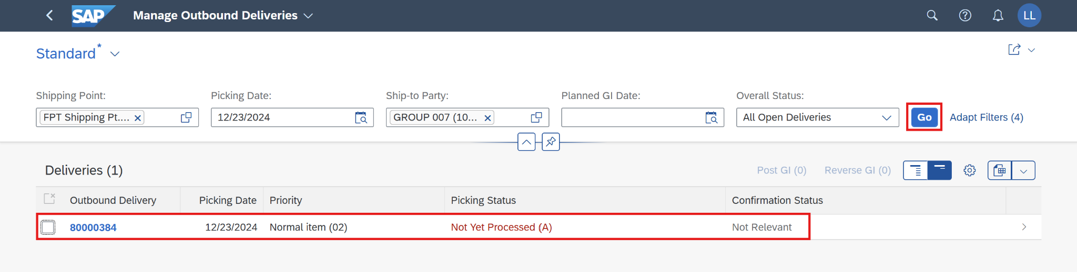

You can see that the picking and posting goods issue still needs to be processed. Click on the line that contains your outbound delivery to get more details.

Click on the *Outbound Delivery* line, and a new *Outbound Delivery* screen will pop up.

Choose the button 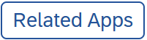-> 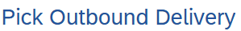

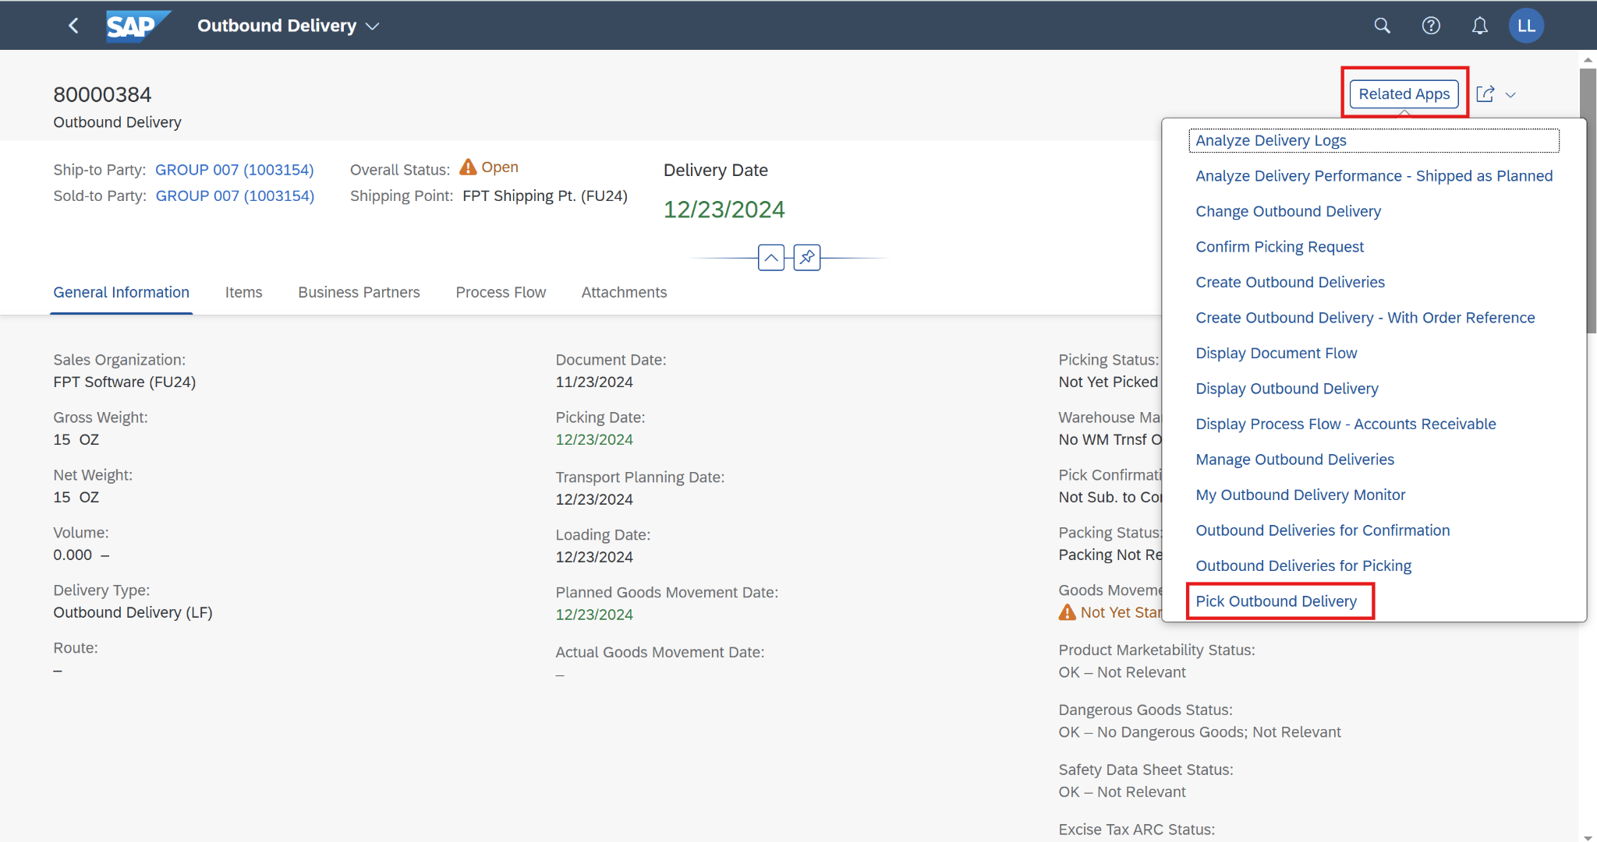

In the *Delivery Items* area, enter the appropriate quantities in the *Picking Quantity* fields: **1**.At the end of the line, click 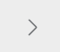 to maintain further details.

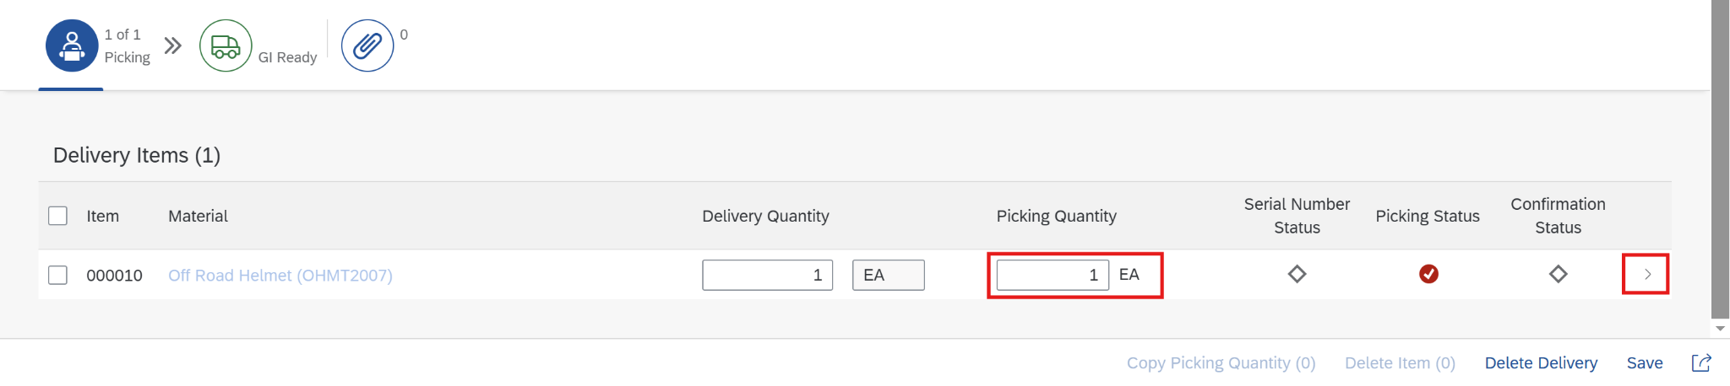

On the next screen, in the *Storage Location* field enter **TG01**.

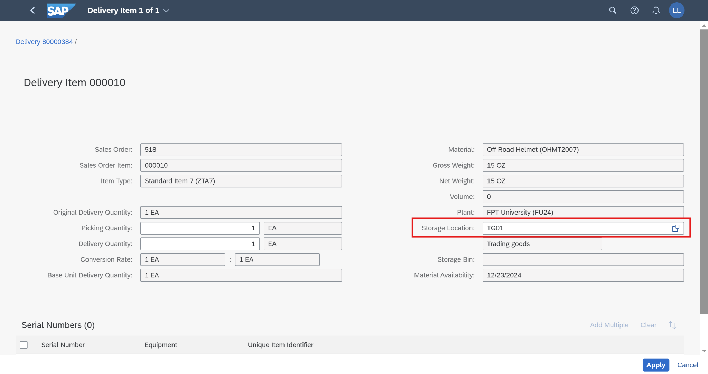

Then click on the button , choose 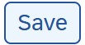, and continue to click on 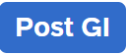.

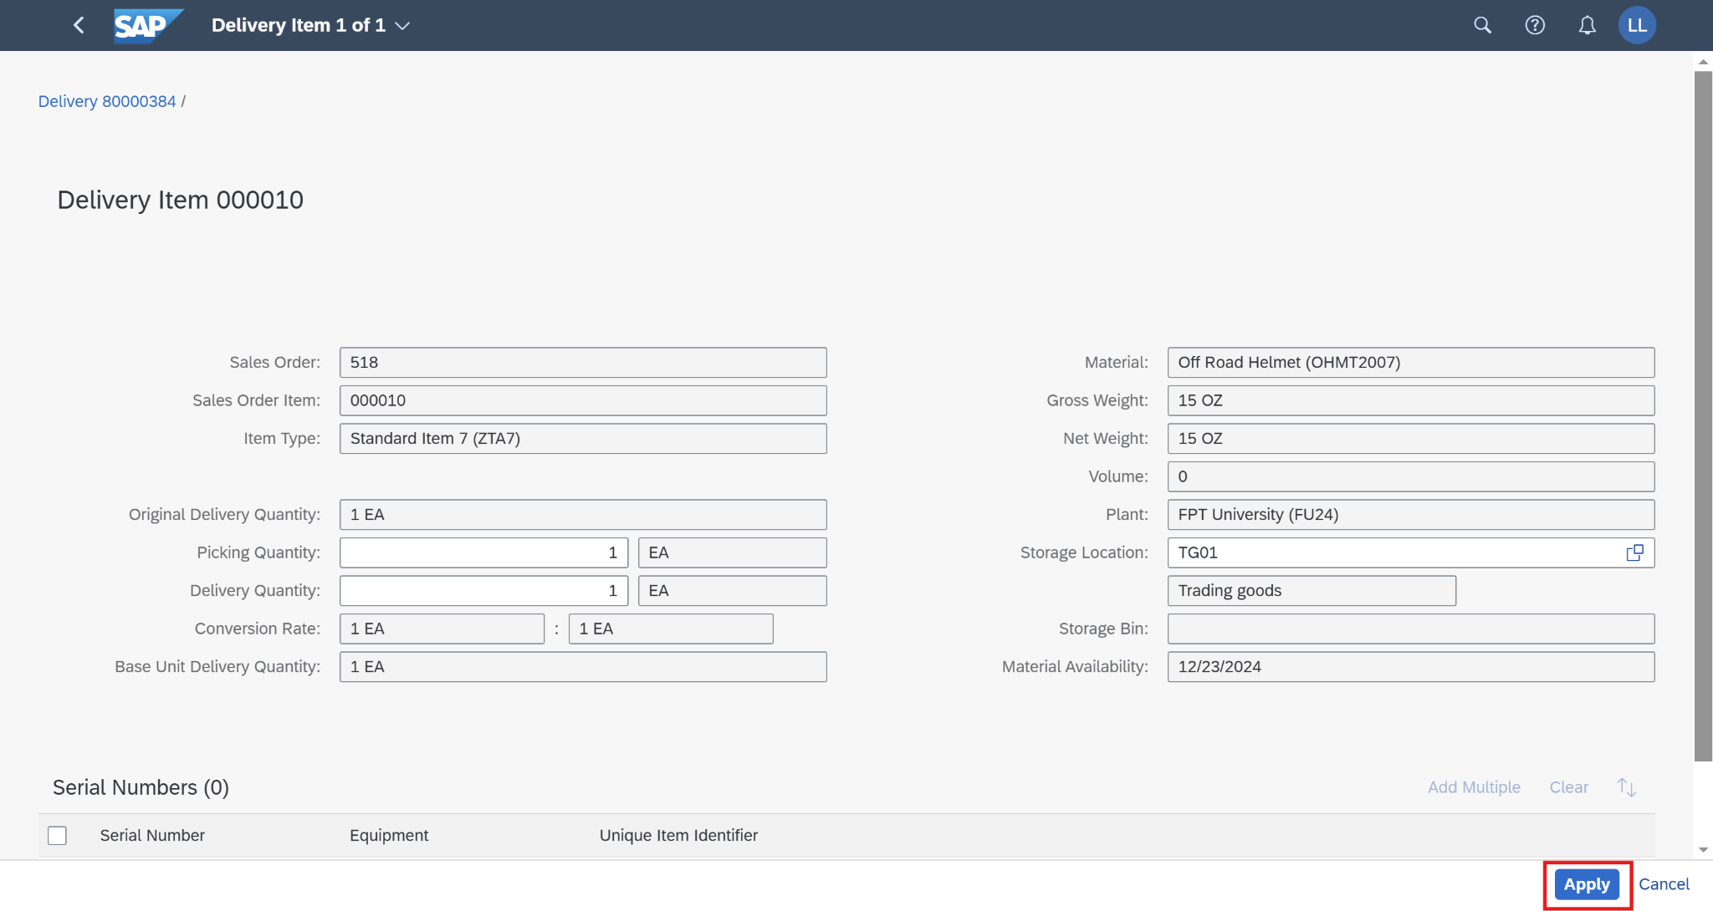

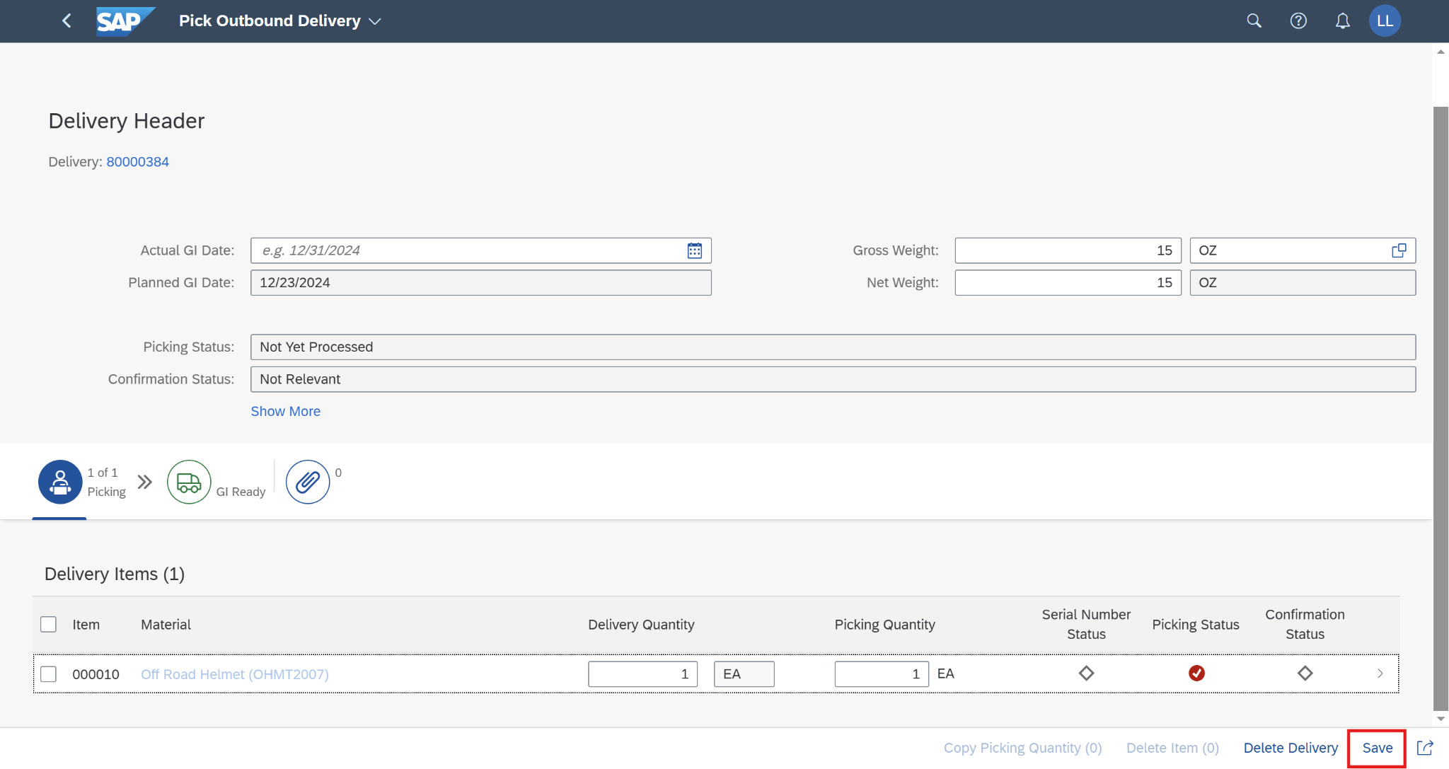

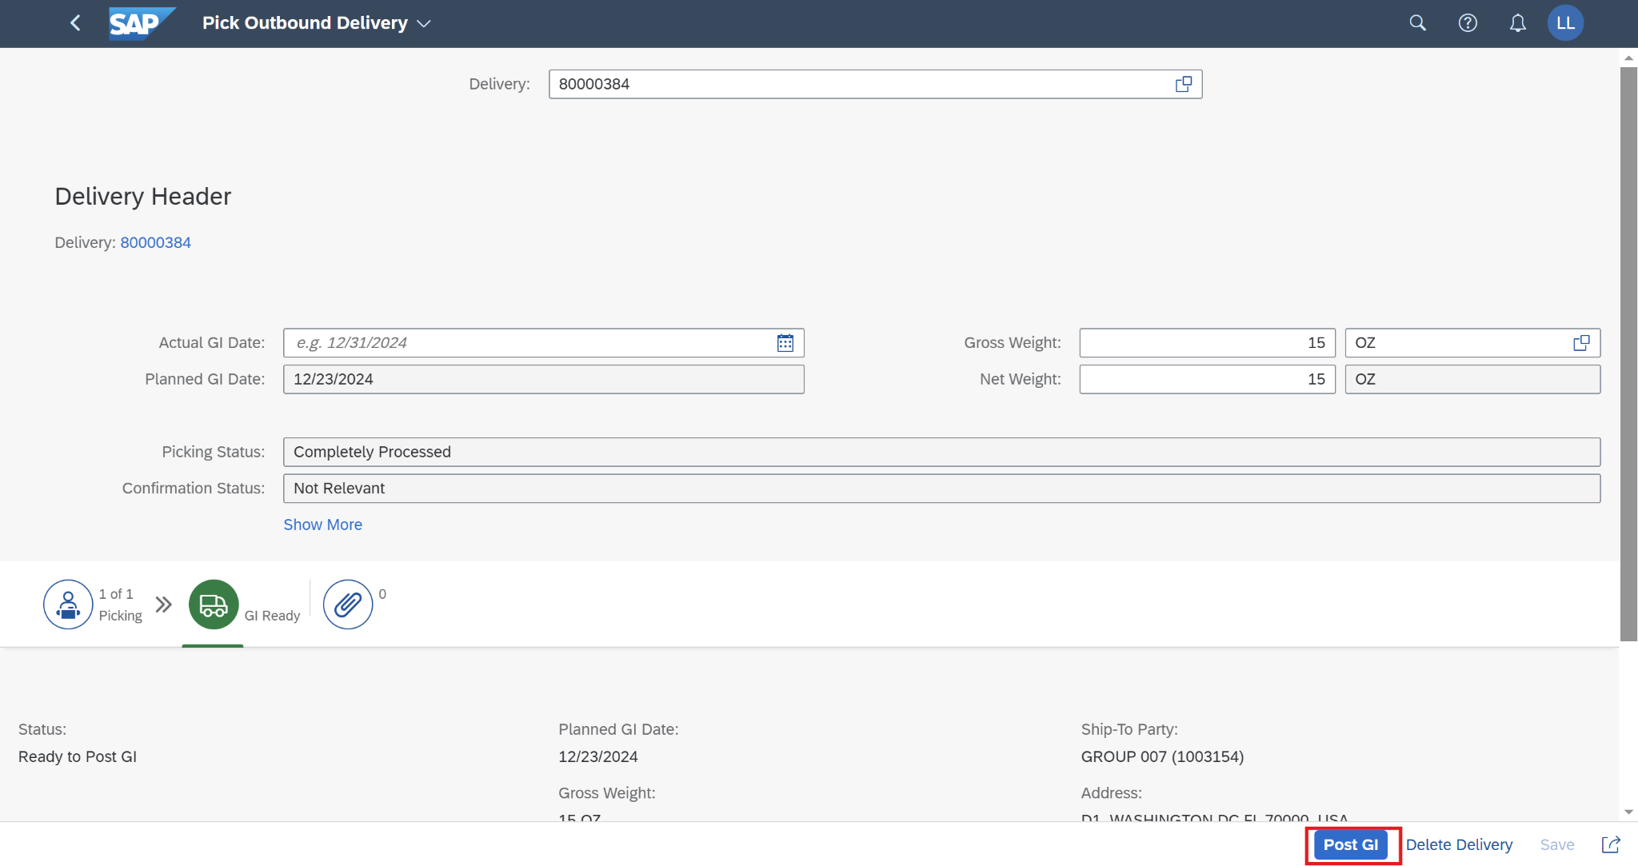

A small message will appear on the screen that announces Goods Issue has been posted successfully.

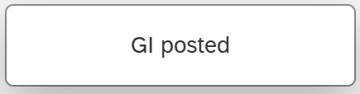

Click on  to return to the SAP Fiori launchpad.

## 2.7 Create Billing Documents

### 2.7.1 Transaction Code

| **T-code** | **Description** |
| --- | --- |
| VF01 | Create Billing Documents |
| VF02 | Change Billing Documents |
| VF03 | Display Billing Documents |

### 2.7.2 Detail Implementation

*(*Note: Please use the T-code for this step)*

In the  search field, enter **VF01** anduse the app *Create Billing Documents - VF01* to create the billing documents. Click on T-code **VF01** - Create Billing Documents.

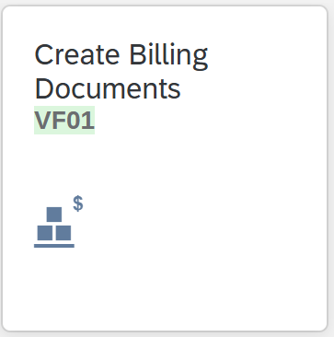

In the *Create Billing Documents* screen, in the field *Document*, enter your **outbound delivery number.** Then click on 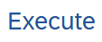(or press *Enter*).

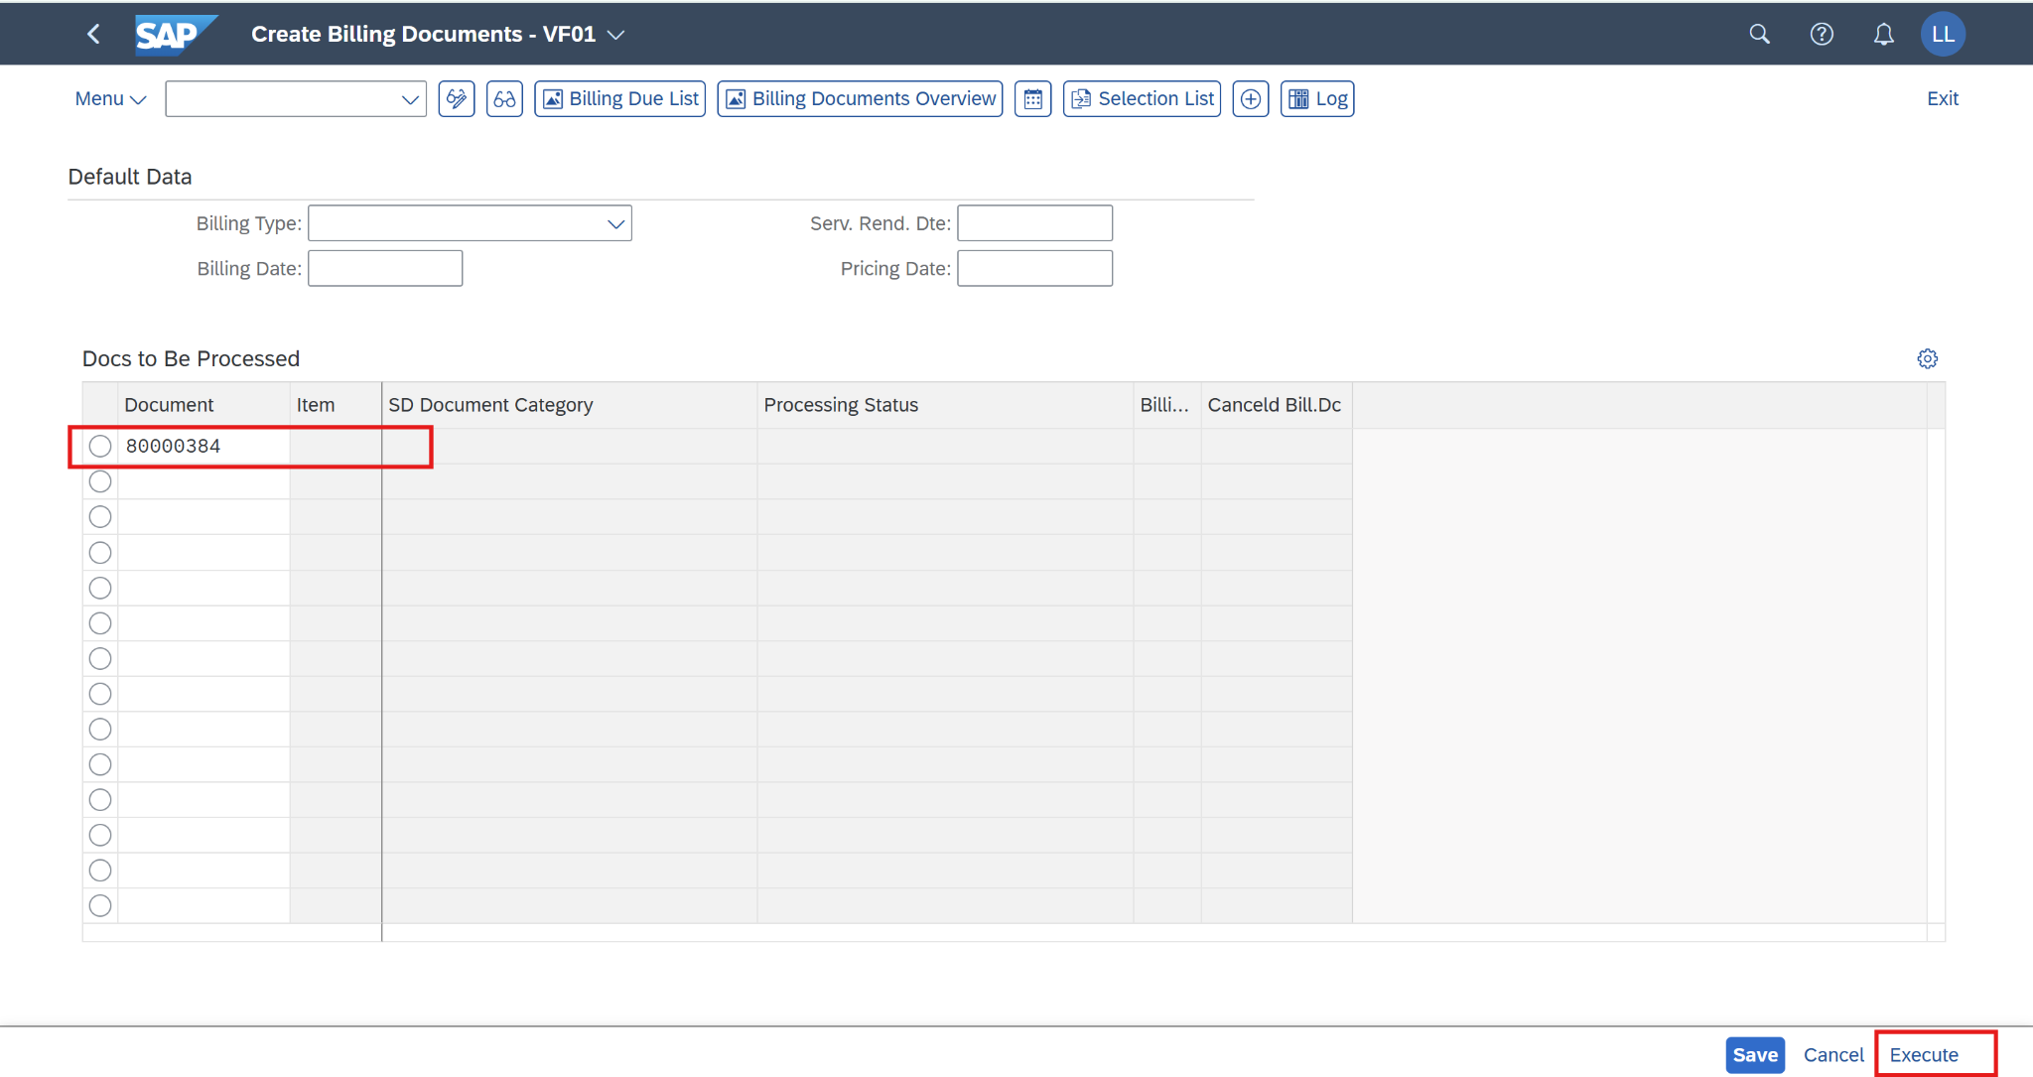

On the *Invoice (ZF2) Create: Overview of Billing Items* screen, and choose *Display header details.*

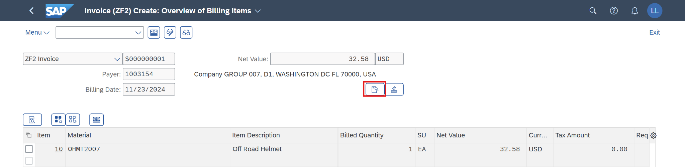

Let’s display the exchange rate value and type in T-code OB08 first:



Now, return to the process, the *Billing Invoice (ZF2) Create: Header Data* screen is displayed, you can view the *Billing Date, Exch. Rate Type,* and *Exchng. Rate Accntg.* fields. If you change the *Billing Date* field, the value in the *Exchng. Rate Accntg.* field is updated directly from the table in T-code OB08. Additionally, the exchange rate field is editable so you also can change it to any random values.

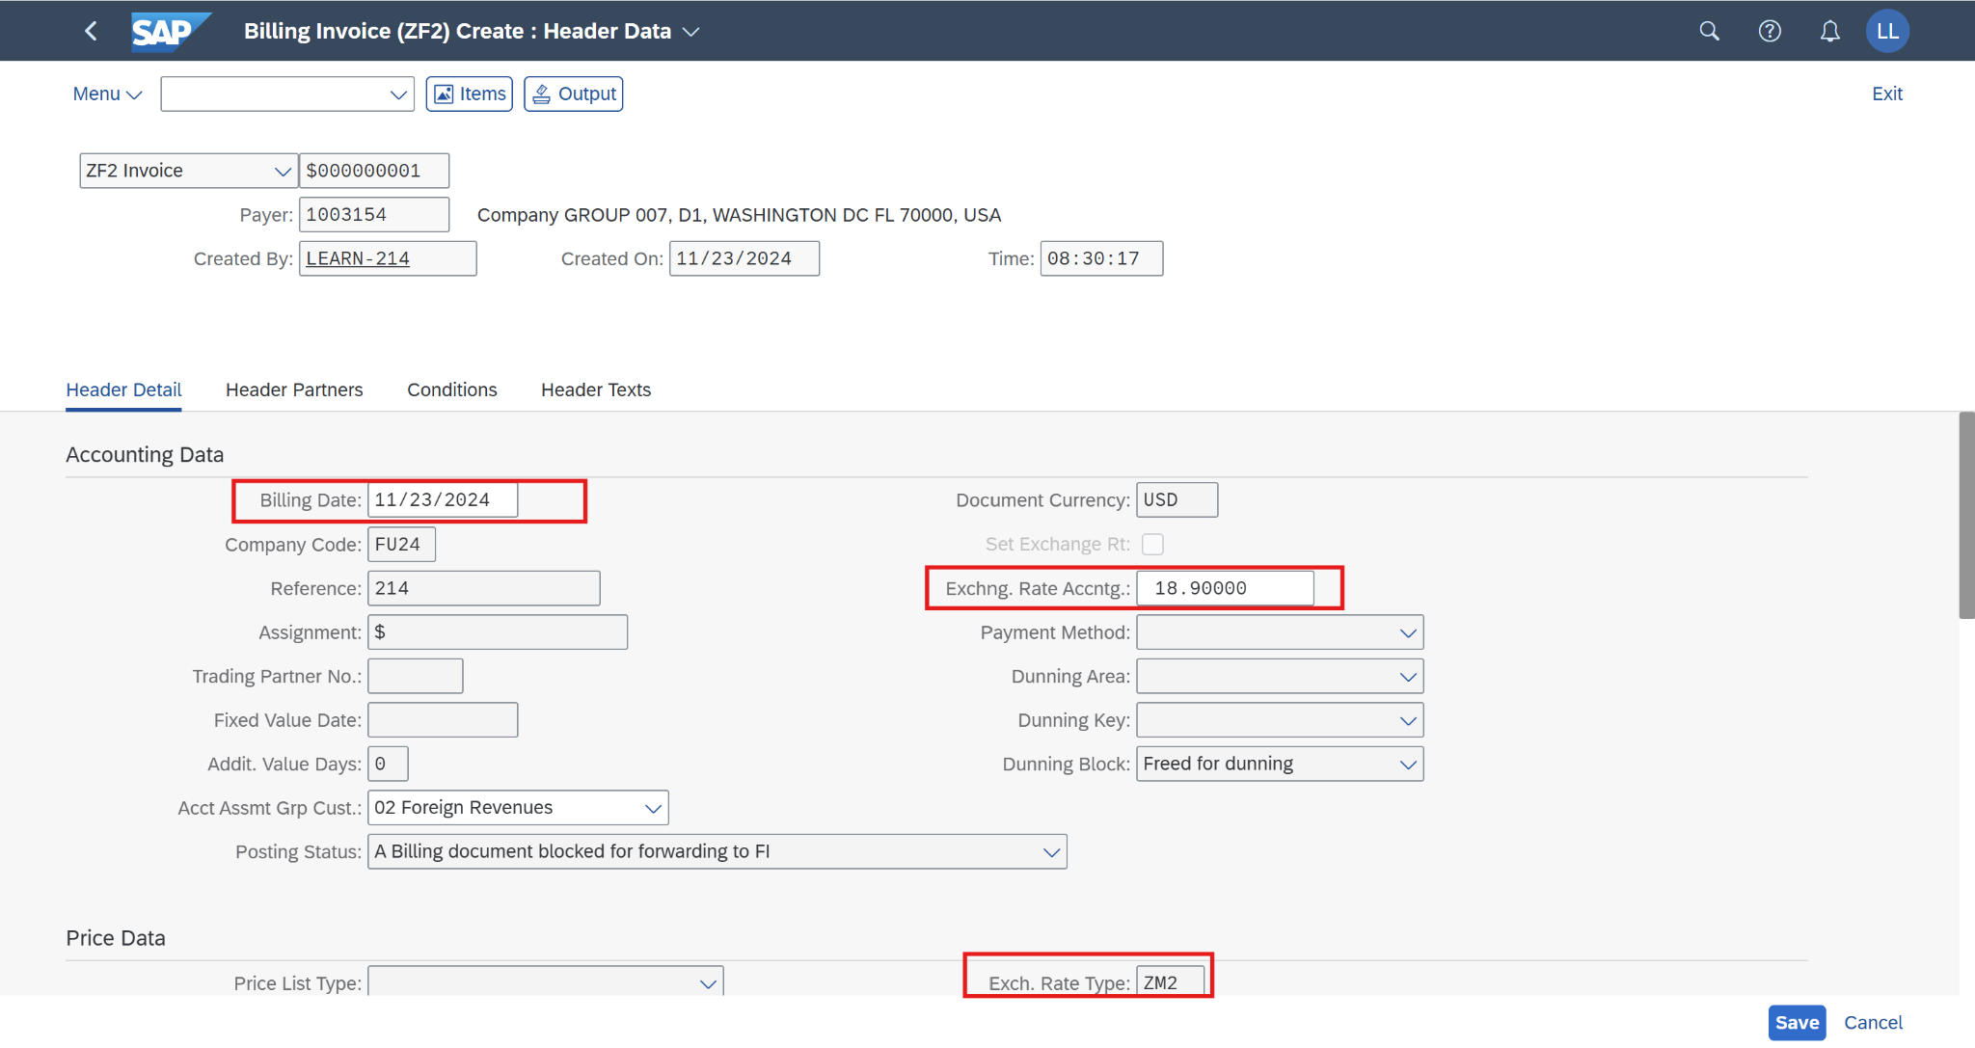

Then click on  and the screen will pop out a message.

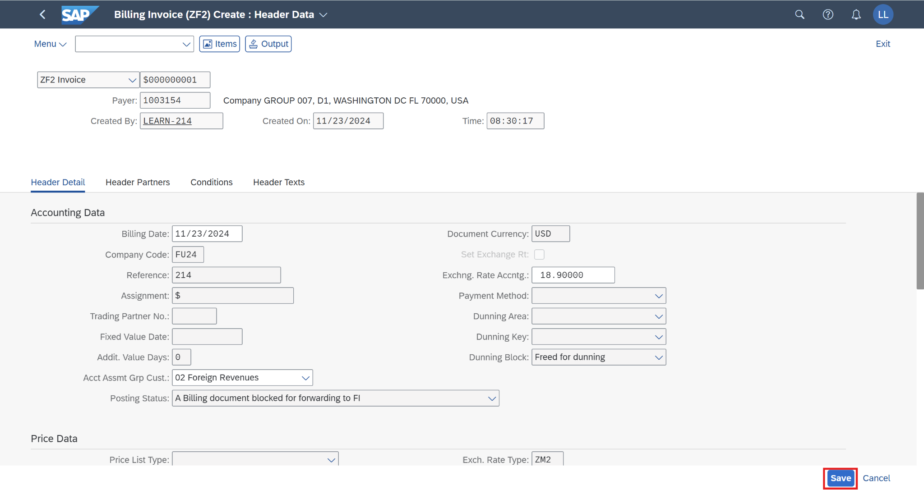



The billing document has been created successfully now. Click on  to return to the SAP Fiori launchpad.

## 2.8 Post Billing Documents & Display Accounting Documents

### 2.8.1 Transaction Code

| **T-code** | **Description** |
| --- | --- |
| VF02 | Change Billing Documents |
| VF03 | Display Billing Documents |

### 2.8.2 Detail Implementation

*(*Note: Please use the T-code for this step)*

In the  search field, enter **VF02** anduse the app *Change Billing Documents* to post the billing document. Click on the application.

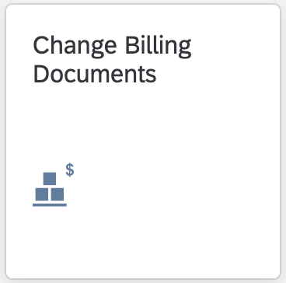

On the *Manage Billing Documents* screen, enter **your billing document number**. Then click on *Release to Accounting* to post the billing documents.

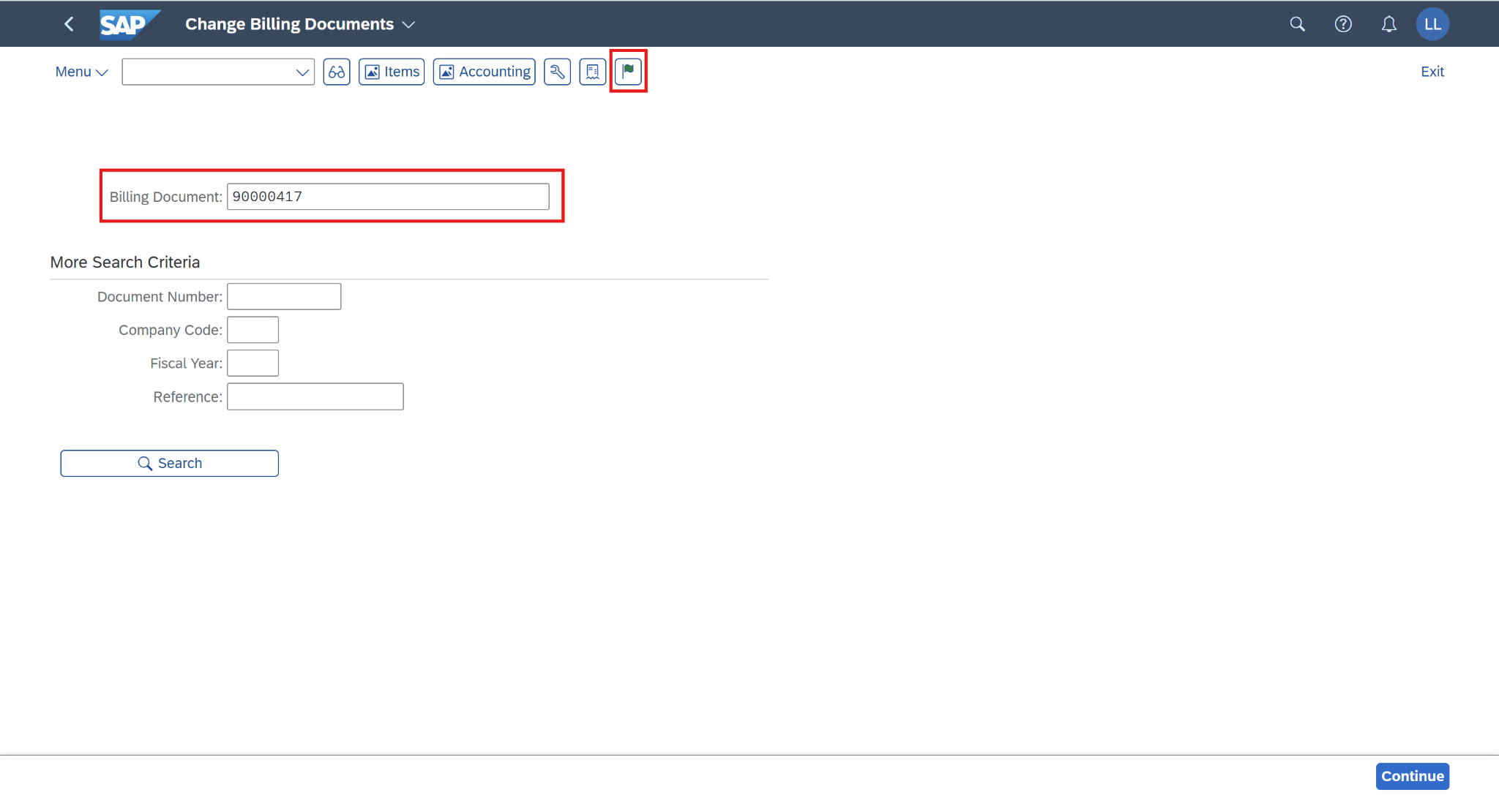

You will receive a notification that the billing document has been posted.

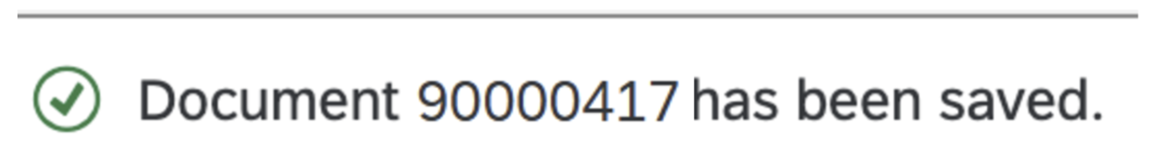

Now, go to display the accounting document to verify that it has already been updated correctly from the billing document. Choose 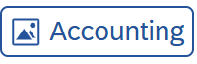on the *Change Billing Documents* screen.

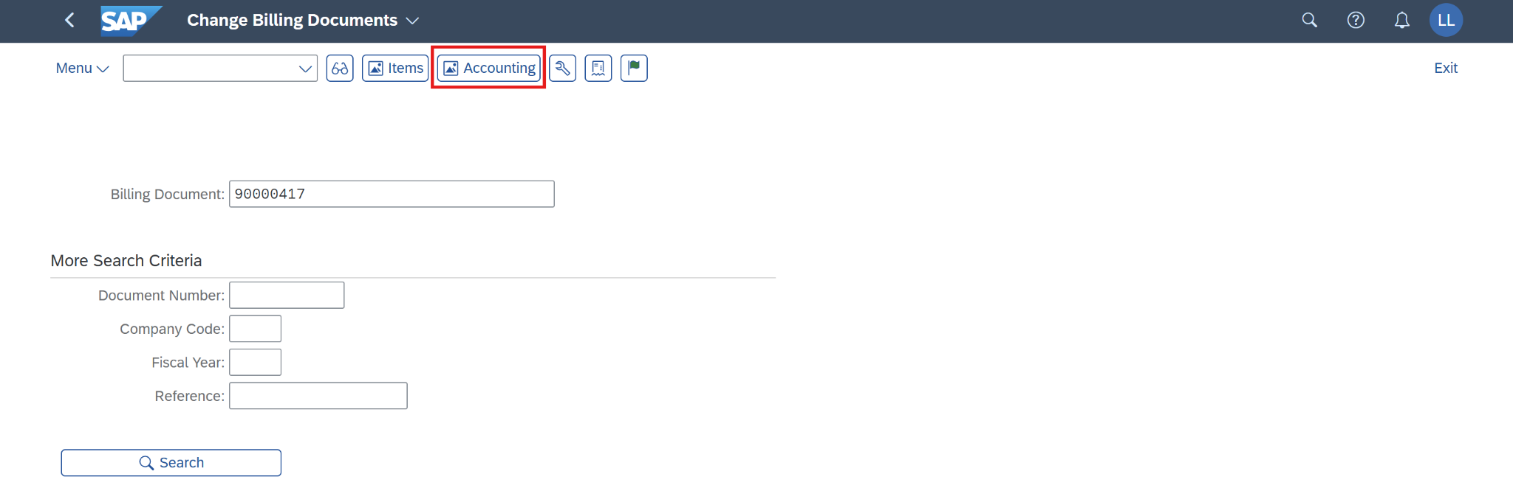

On the *List of Documents in Accounting* screen, choose the line *Accounting document* and click on *Display Document (F2).*

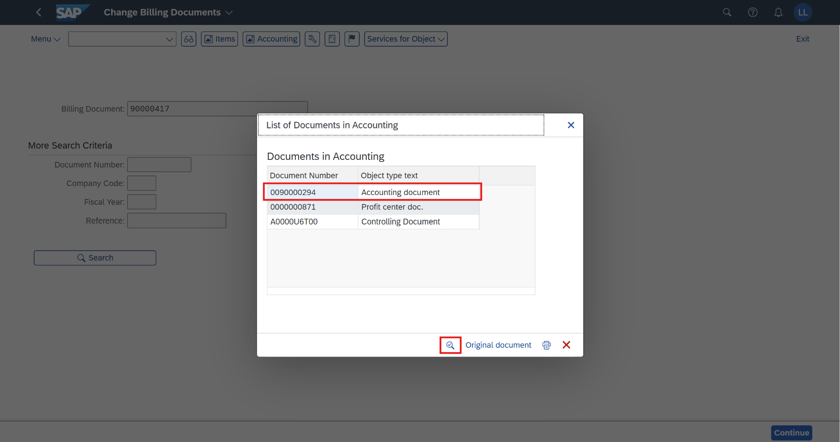

On the *Display Document: Data Entry View* screen, choose *Display Document Header (F5).*

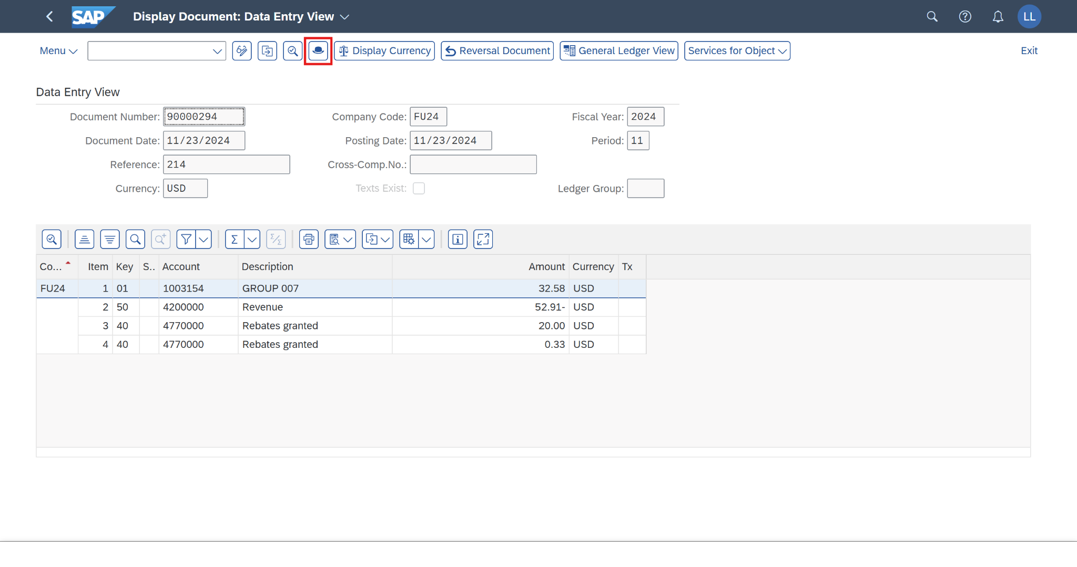

The *Document Header: FU24 Company Code* screen will pop out. Now, you can view the *Exchange rate* field as **18.90000**. This value is updated correctly from the *Billing Header* in the *Create Billing Documents* step.

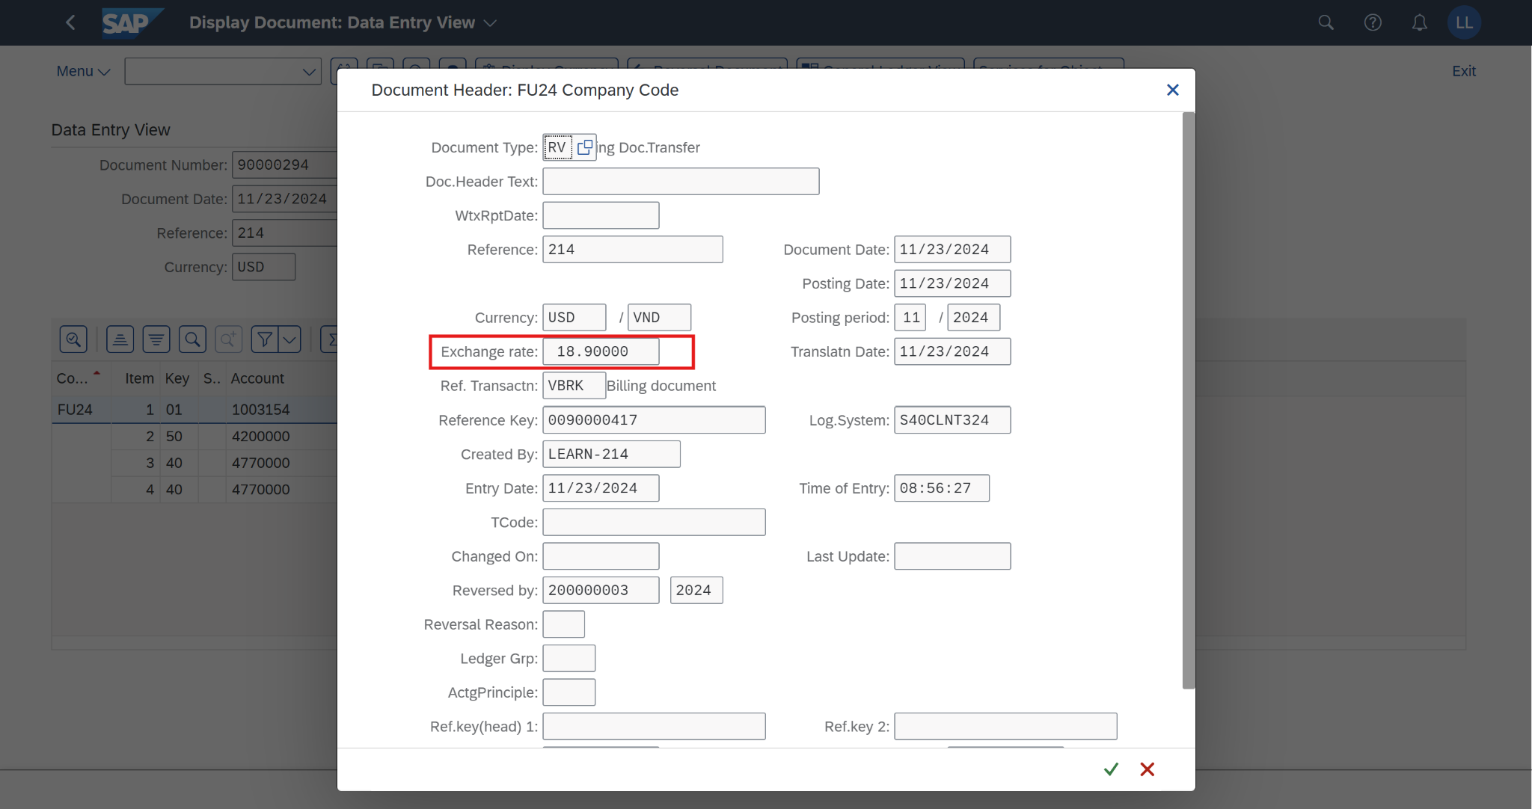

Click on  to return to the SAP Fiori launchpad.

## 2.9 Change Billing Documents

*(*Note: This step is processed in case Billing Documents - VF01 hasn’t been posted yet)*

### 2.9.1 Transaction Code

| **T-code** | **Description** |
| --- | --- |
| VF02 | Change Billing Documents |

### 2.9.2 Detail Implementation

*(*Note: Please use the T-code for this step)*

Before changing the billing document, the screenshot below shows that the billing document number we will use has not been posted in the journal entry.

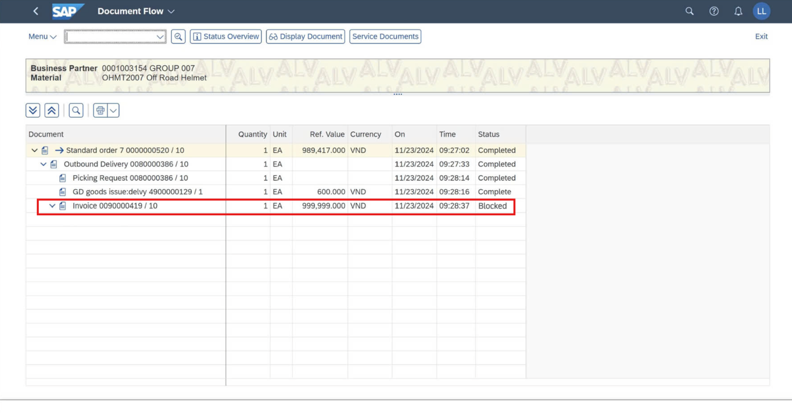

Next, in the  search field, enter **VF02** anduse the app *Change Billing Documents - VF02* to change the billing documents. Click on T-code **VF02** - Change Billing Documents.

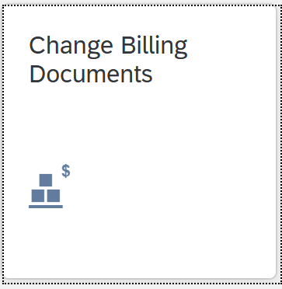

The *Change Billing Documents* screen will pop out. The billing document number in the previous step will be automatically filled in the *Billing Document* field. Click on 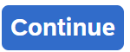 (or press *Enter*).

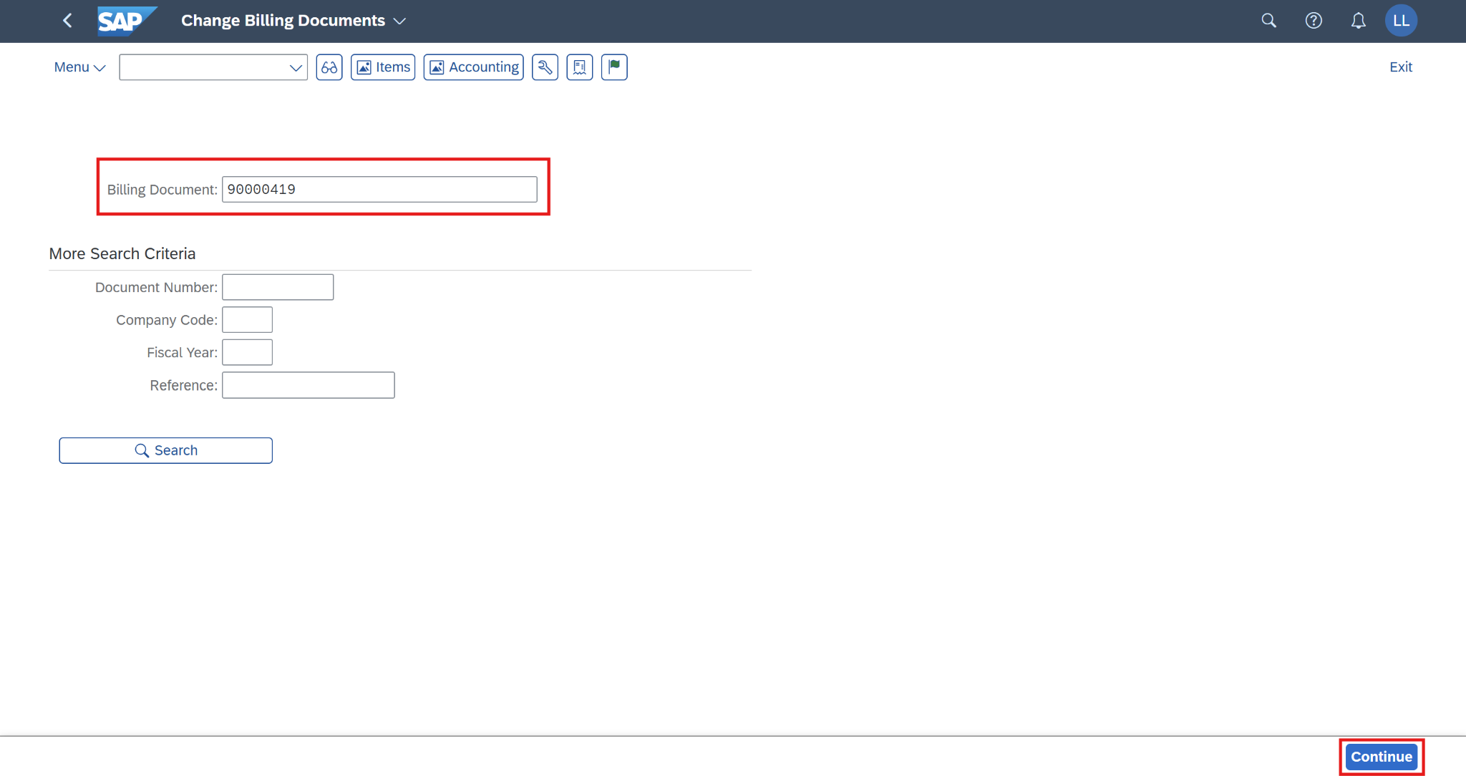

On the *Invoice (ZF2) 90000419 Change: Overview of Billing Items* screen, choose *Display header details.*

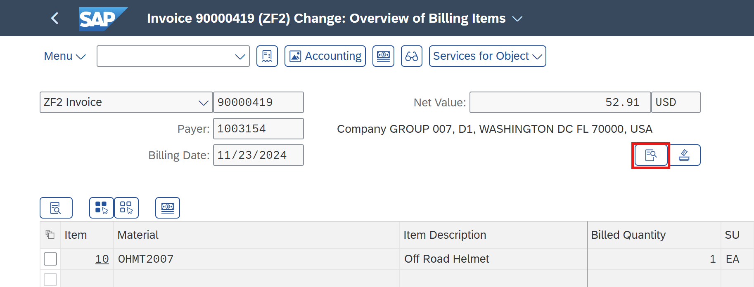

The *Billing Invoice 90000419 (ZF2) Change: Header Data* screen is displayed, you can view the *Billing Date* and *Exchng. Rate Accntg.* fields. If you change the *Billing Date* field, the value in the *Exchng. Rate Accntg.* field is updated directly from the table in T-code OB08. Additionally, the exchange rate field is editable so you also can change it to any random values.

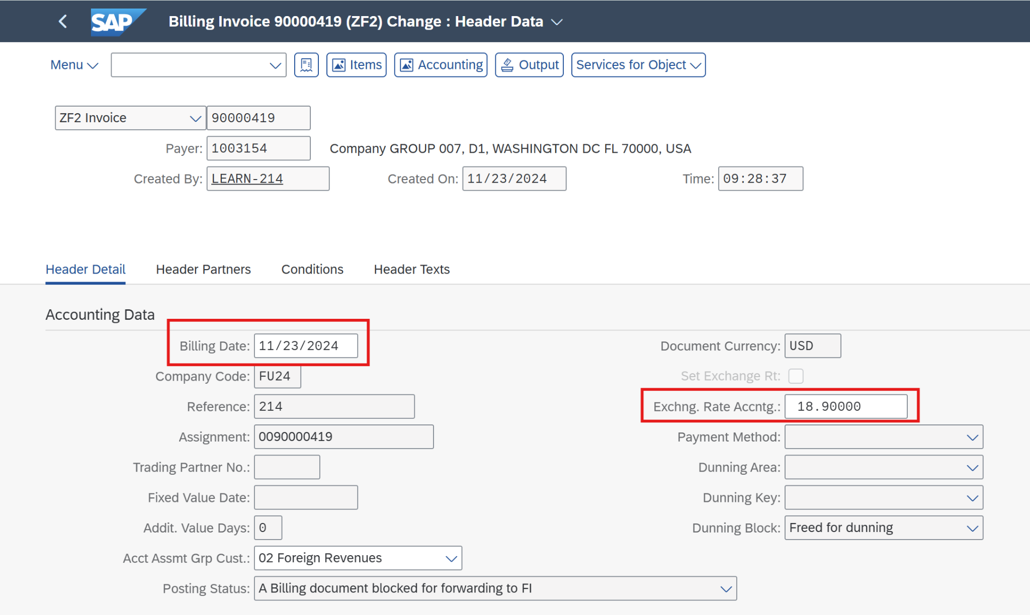



**(You can display this table in T-code OB08)**

Make a change in the *Exchng. Rate Accntg.* field (from **18.90000** to **28.90000**).

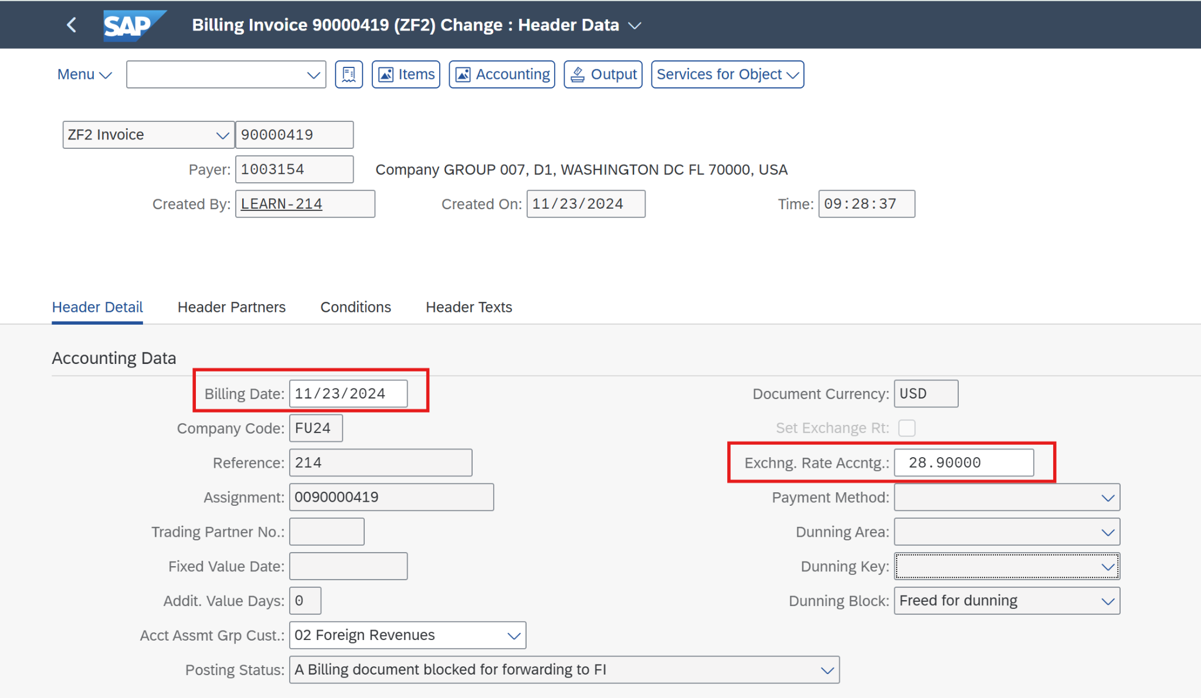

Press *Enter*, and a small message will pop out on the screen. Choose to continue the step.

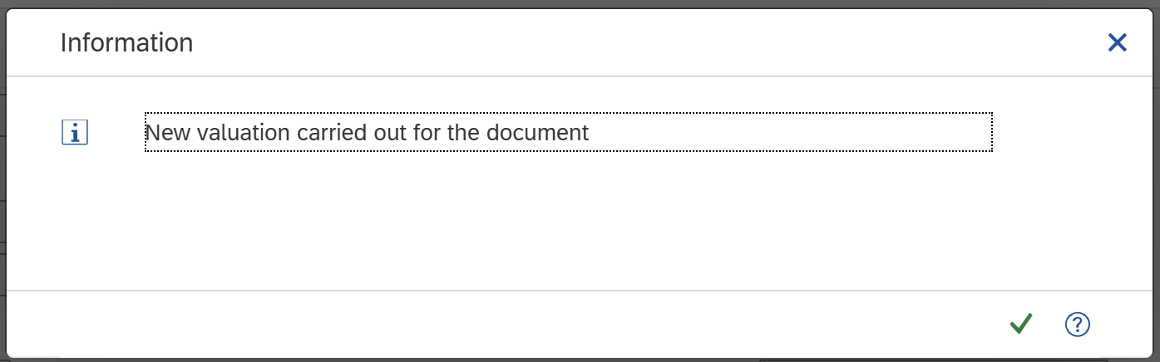

Then click on  and the screen will pop out a message.

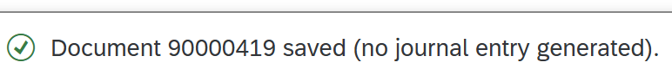

The billing document has been changed successfully now. Click on  to return to the SAP Fiori launchpad.

## 2.10 Post Billing Documents & Display Accounting Documents

### 2.10.1 Transaction Code

| **T-code** | **Description** |
| --- | --- |
| VF02 | Change Billing Documents |
| VF03 | Display Billing Documents |

### 2.10.2 Detail Implementation

*(*Note: Please use the T-code for this step)*

In the  search field, enter **VF02** anduse the app *Change Billing Documents* to post the billing document. Click on the application.



On the *Manage Billing Documents* screen, enter **your billing document number**. Then click on *Release to Accounting* to post the billing documents.

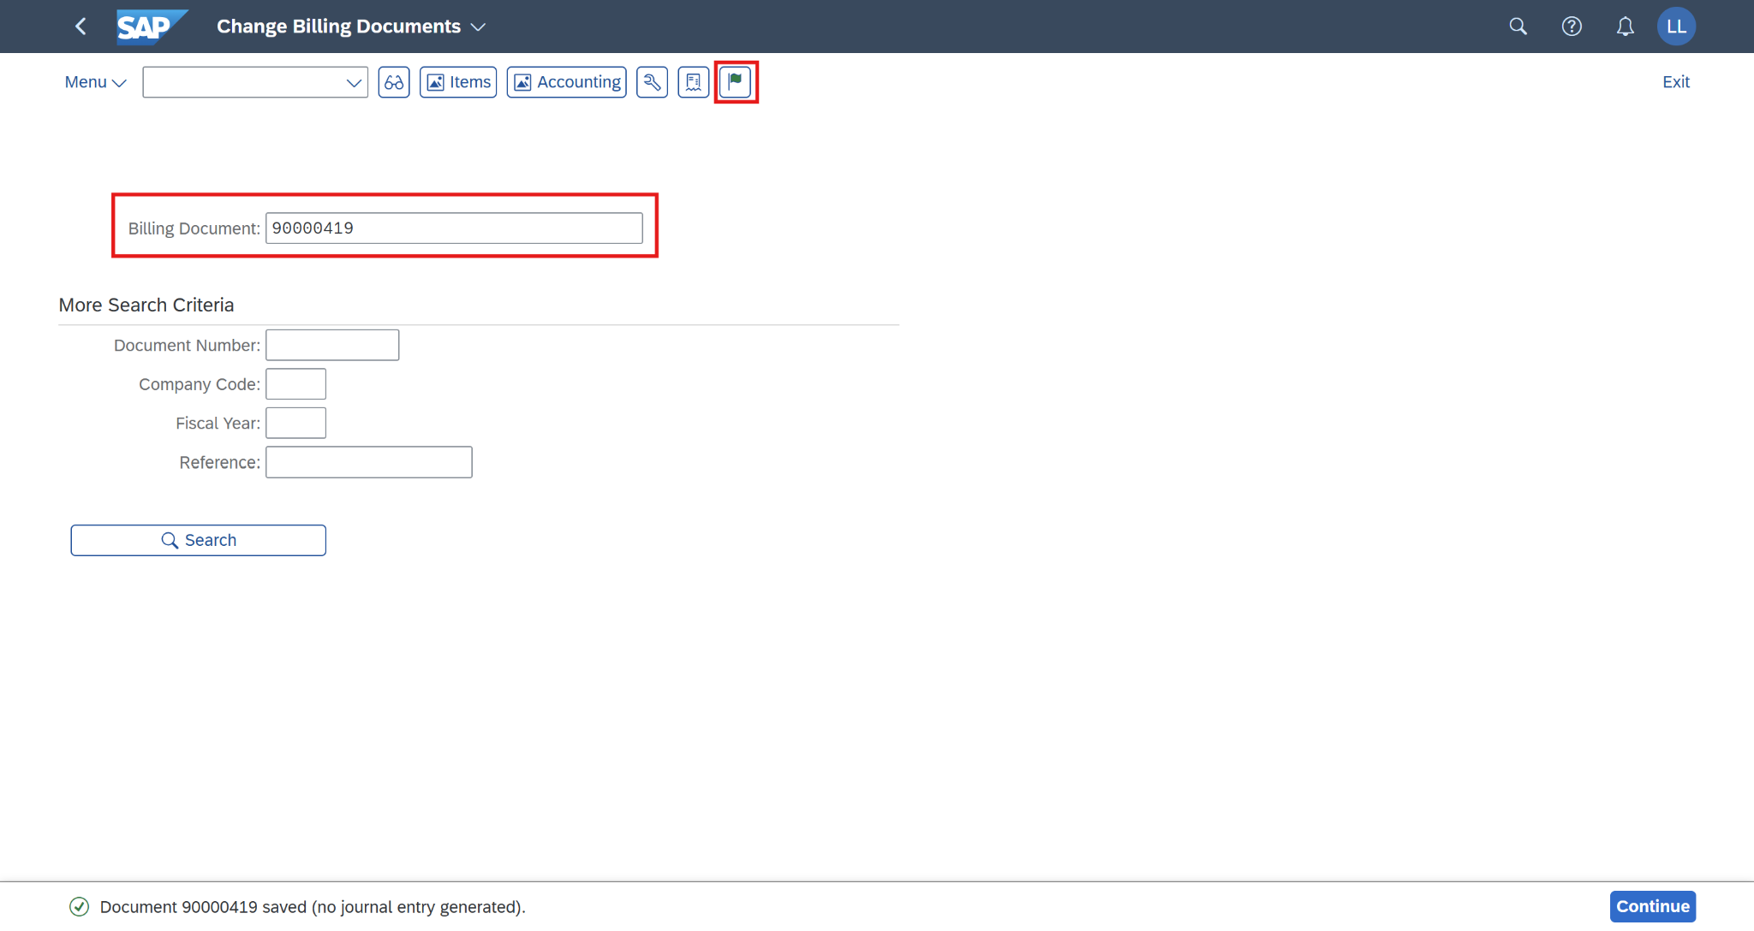

You will receive a notification that the billing document has been posted.

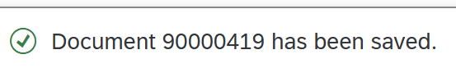

Now, go to display the accounting document to verify that it has already been updated correctly from the billing document. Choose on the *Change Billing Documents* screen.

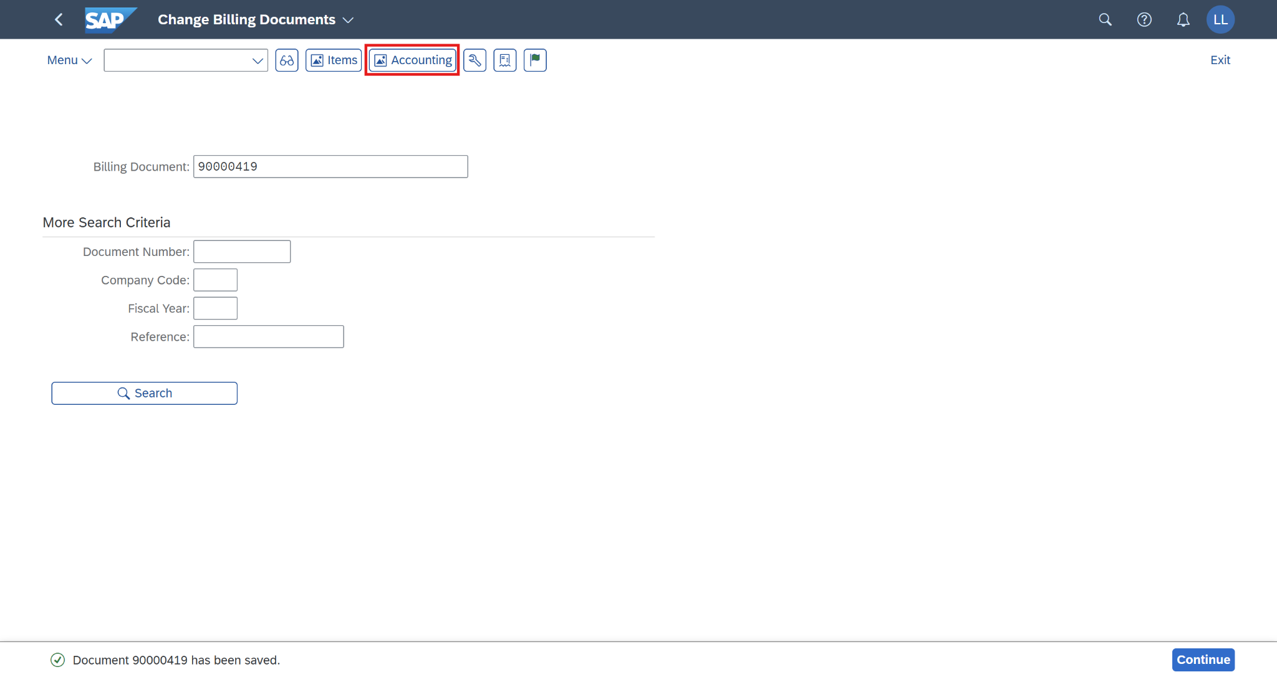

On the *List of Documents in Accounting* screen, choose the line *Accounting document* and click on *Display Document (F2).*

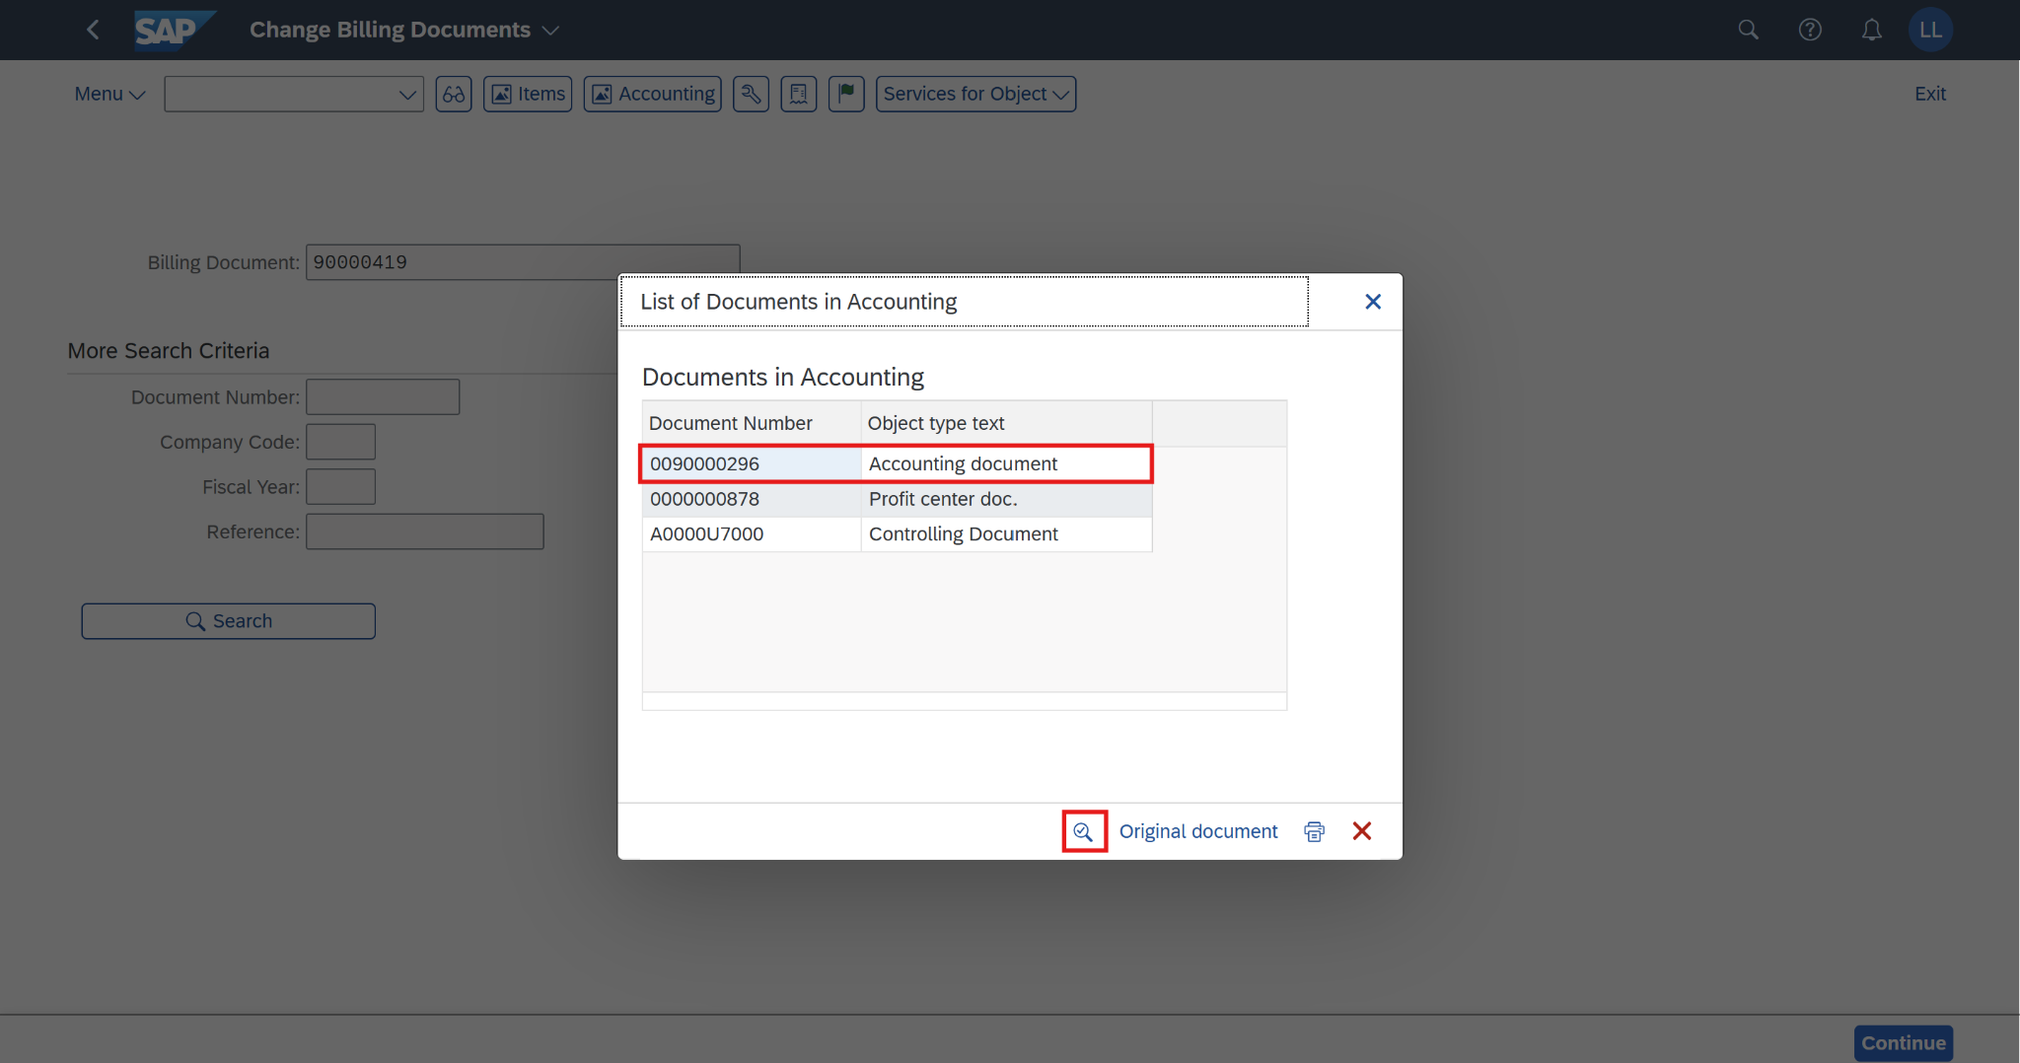

On the Display Document: Data Entry View screen, choose *Display Document Header (F5).*

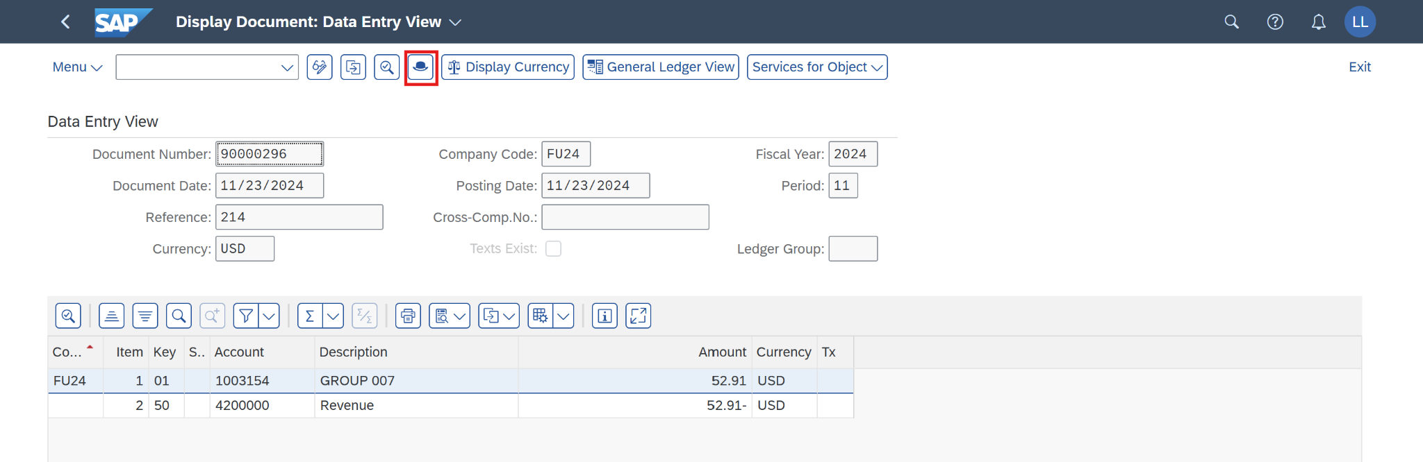

The *Document Header: FU24 Company Code* screen will pop out. Now, you can view the *Exchange rate* field as **28.90000**. This value is updated correctly from the *Billing Header* in the *Create Billing Documents* step after changing the exchange rate field in the *Billing Header* from **18.90000** to **28.90000** in T-code VF02.

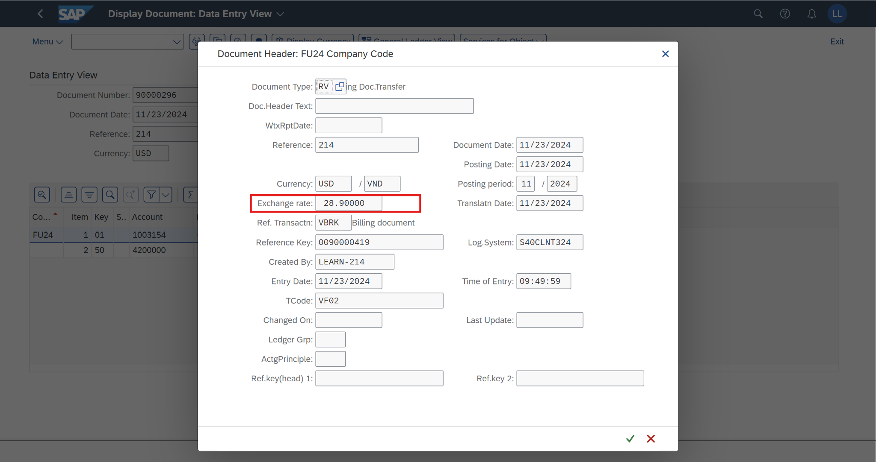

Click on  to return to the SAP Fiori launchpad.

### 